**SD3489 - Practical DevOps – CI/CD on AWS**

Table of Contents

[1] Introduction 2

[2] Prerequisites 2

[3] Git Repositories 2

[4] Provisioning infras using Terraform 2

Configure AWS 2

Provisioning Infras 3

[5] Setup Jenkins 8

Install 8

Additional Jenkins plugins 13

Setup Credentials 15

[Create a Job Pipeline) Jenkins 16

Build images and push to AWS ECR 18

Config Webhook to trigger the Jenkins Pipeline from Github hook 22

[6] ArgoCD 26

Install 26

Sign in to ArgoCD 27

Create an application 28

[7] Monitoring with Prometheus and Grafana 30

Installation 30

Import metrics to Dashboard 31

Monitoring via UI (Dashboard) 32

# [1] Introduction

* Provisioning AWS services using Terraform
* Setting up Jenkins CI and use GitOps for the CD pipeline.
* Setting up Monitoring Prometheus and Grafana.

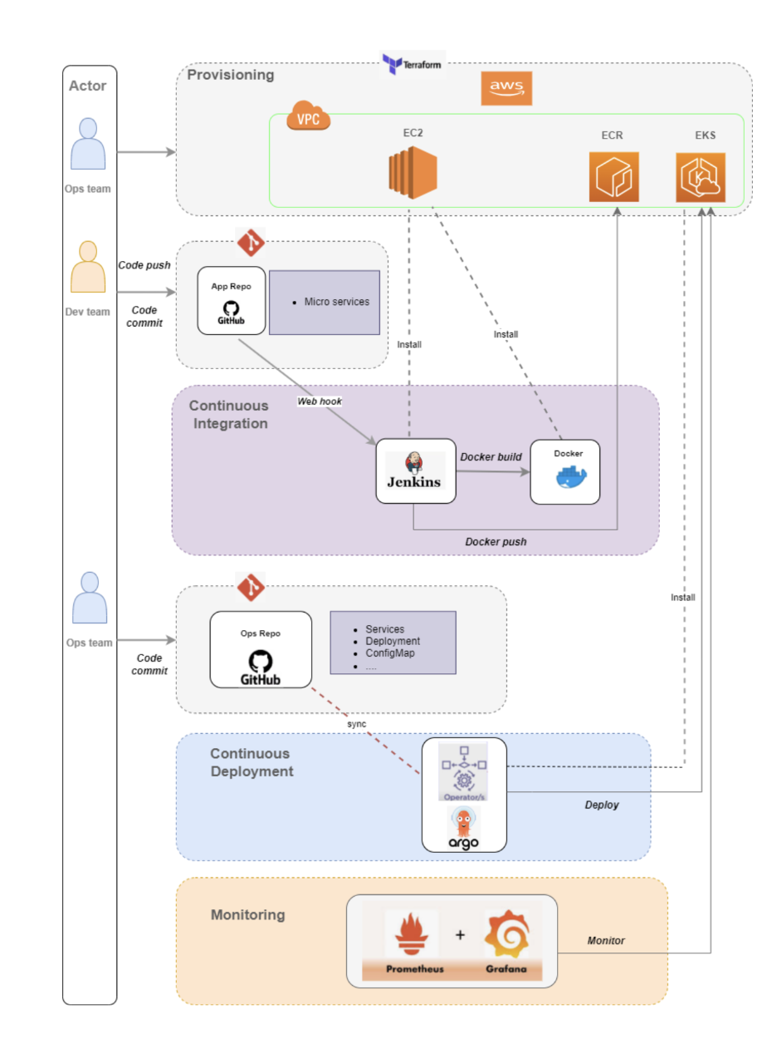

# [2] Prerequisites

* Have an AWS account.
* AWS CLI installed.
* Terraform installed.
* Kubectl installed.
* Helm installled.

# [3] Git Repositories

* Infrastructure (infras) as code
  + <https://github.com/toan-le-theout/sd3489_aws_infrastructure>
* MSA application
  + <https://github.com/toan-le-theout/sd3489_msa>

# [4] Provisioning infras using Terraform

## Configure AWS

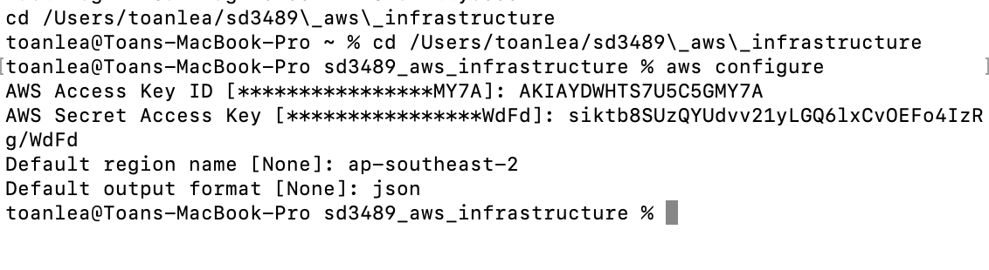

## Provisioning Infras

Clone infras repo from the Github

Go to sd3489_aws_infrastructure, do below steps:

* **terramform init**

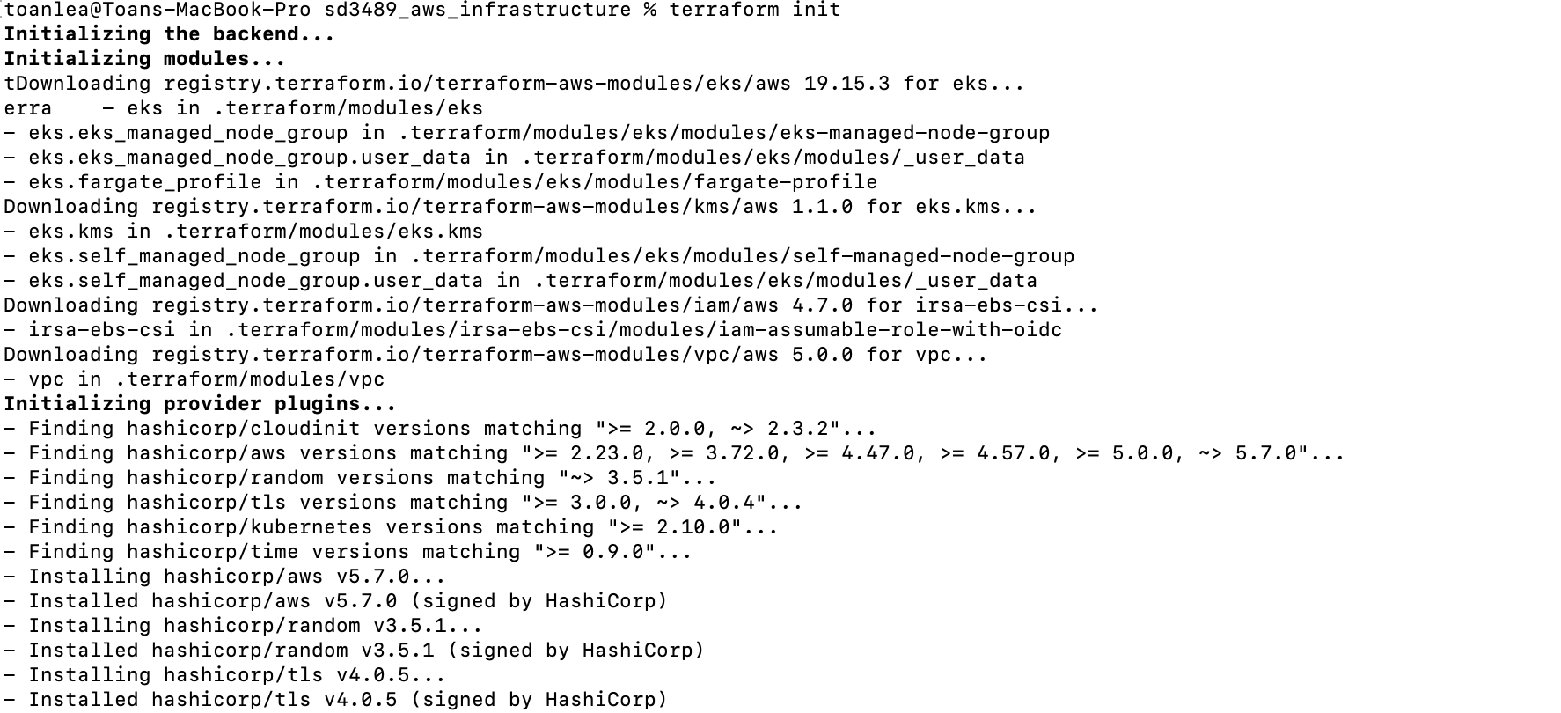

* **terraform plan**

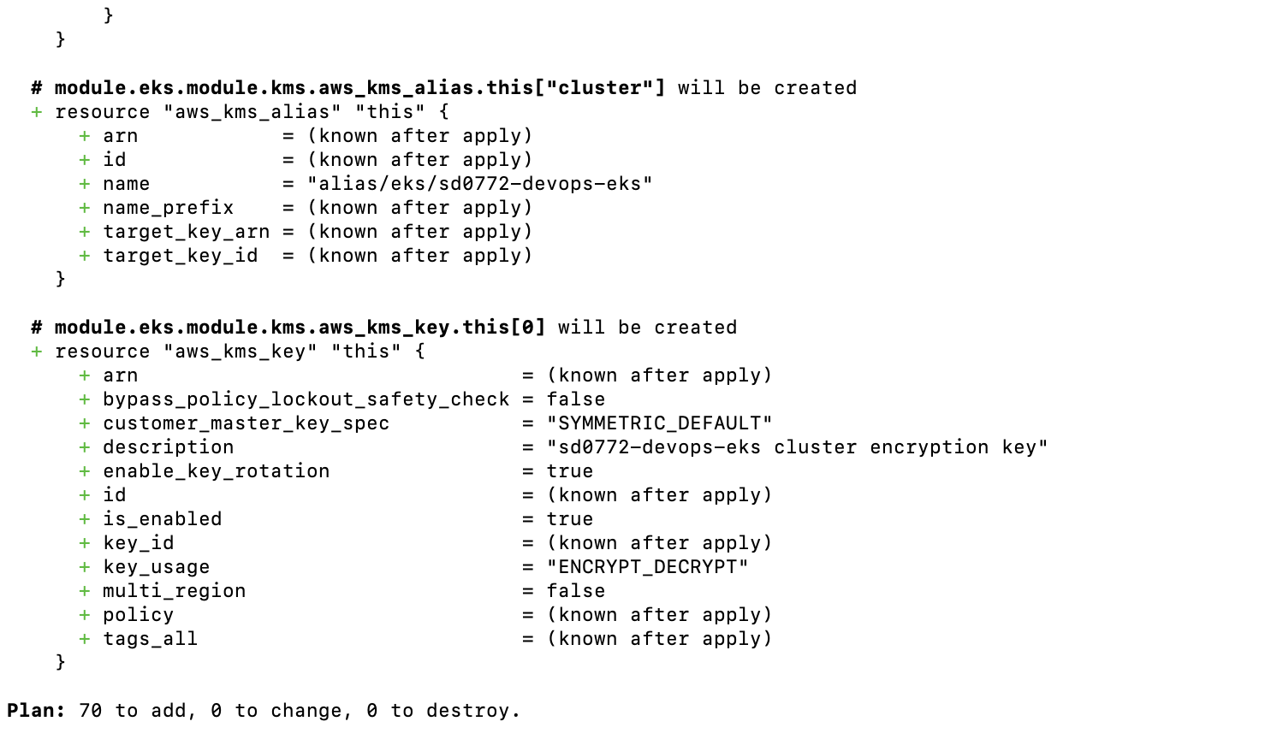

* **terramform apply**

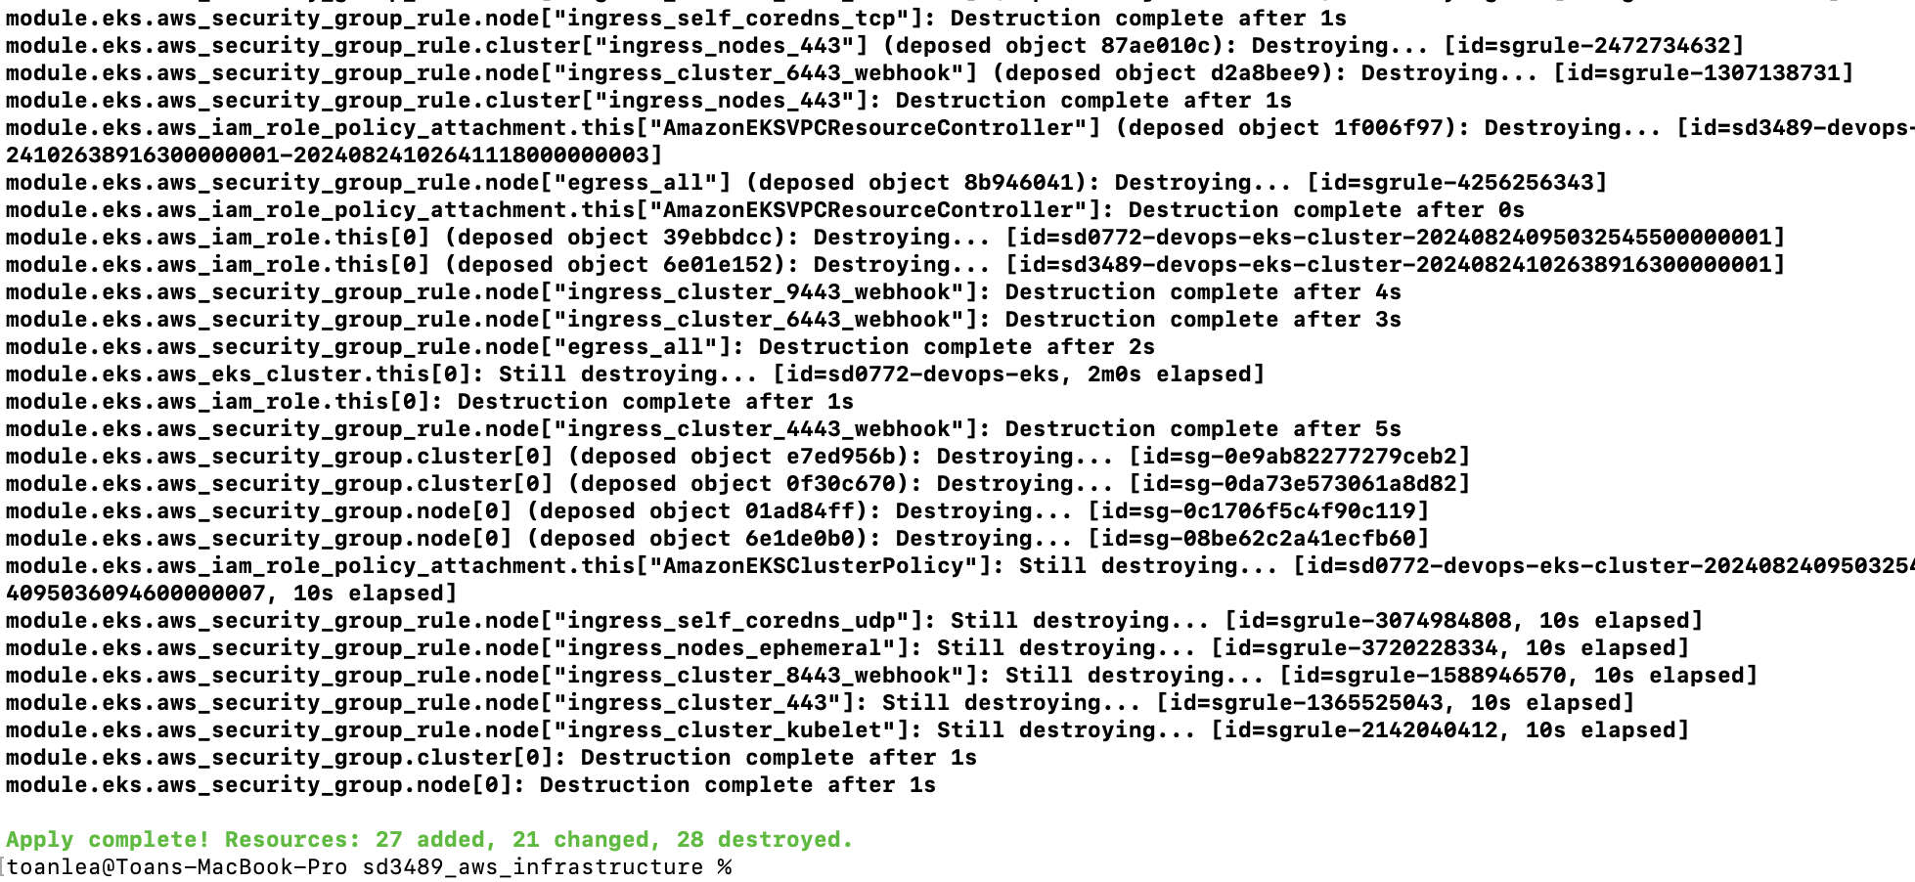

**Notes: Go to AWS Console to create a key pair called [sd3489_ec2_keypair], download and move it inside [sd3489_aws_inftrastructure] folder.**

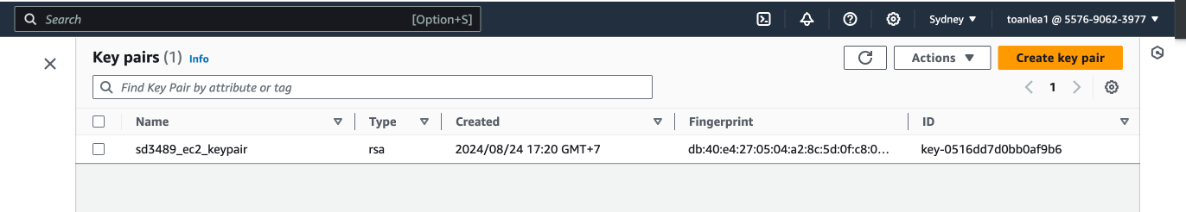

**Checking AWS services are provisioned by Terraform**

* **AWS ECR**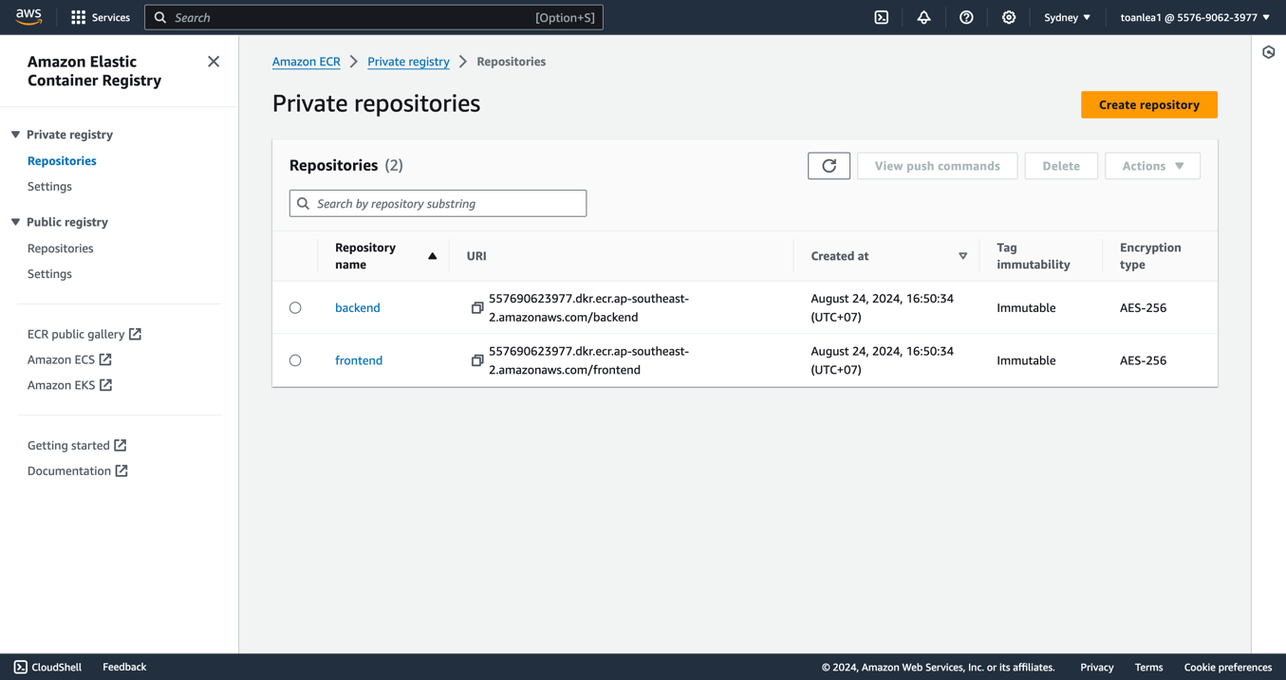
* **AWS EKS  
    
  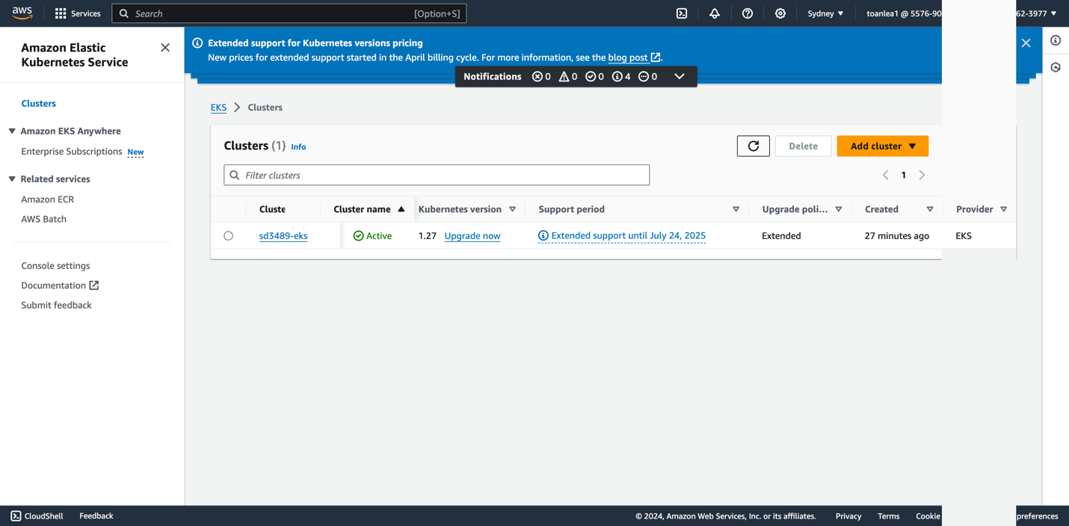**
* **AWS VPC  
    
  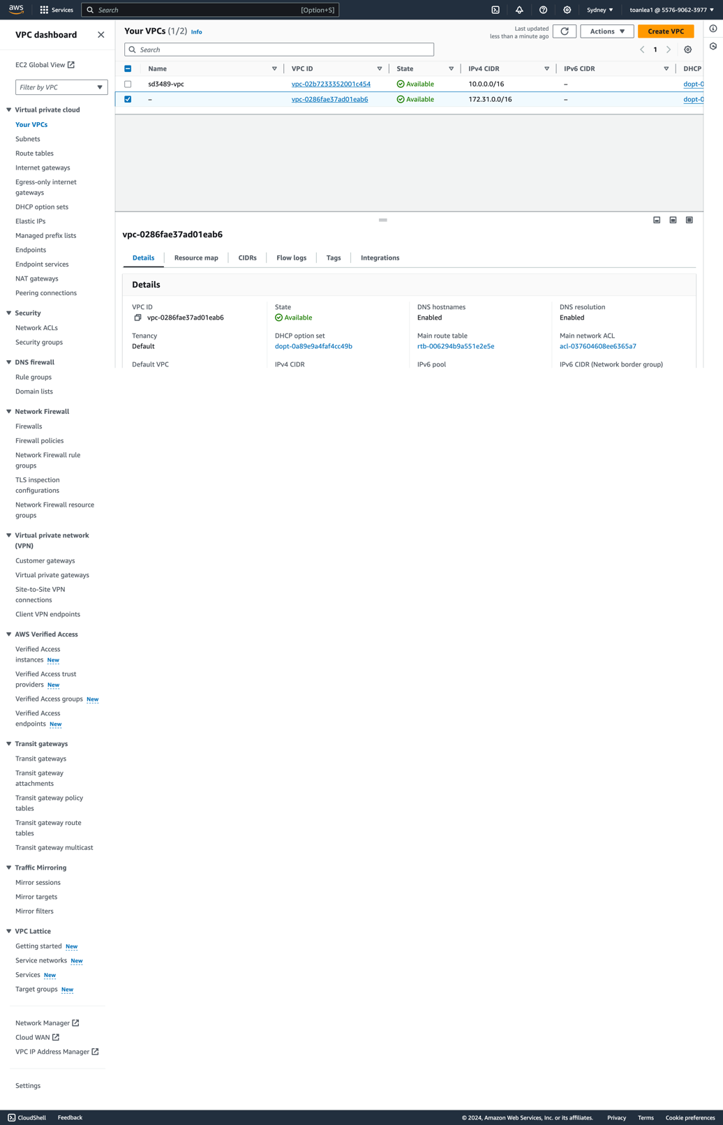**
* **AWS EC2 instances  
    
  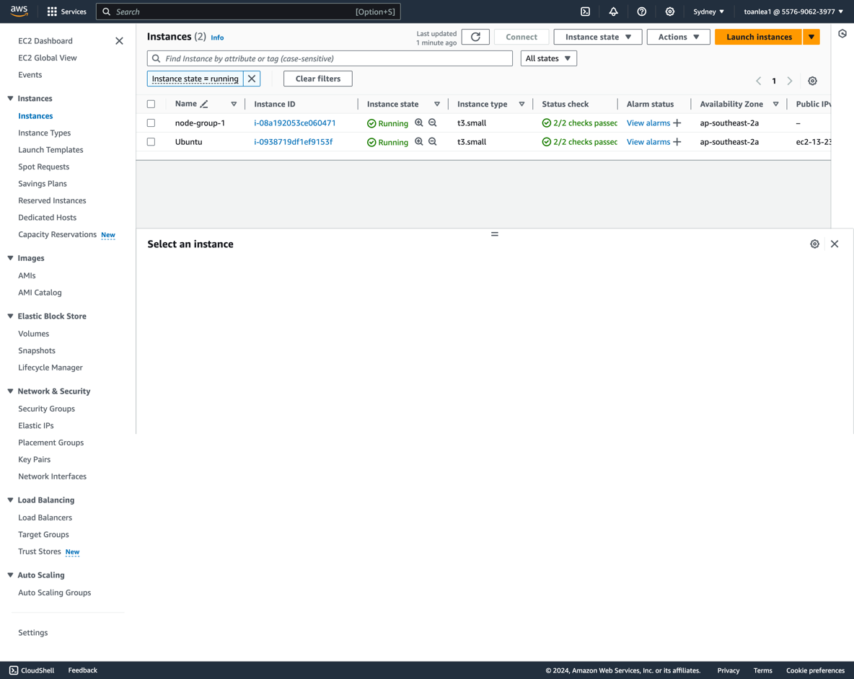**

**My public IP for ubuntu as below:** 13.237.60.106

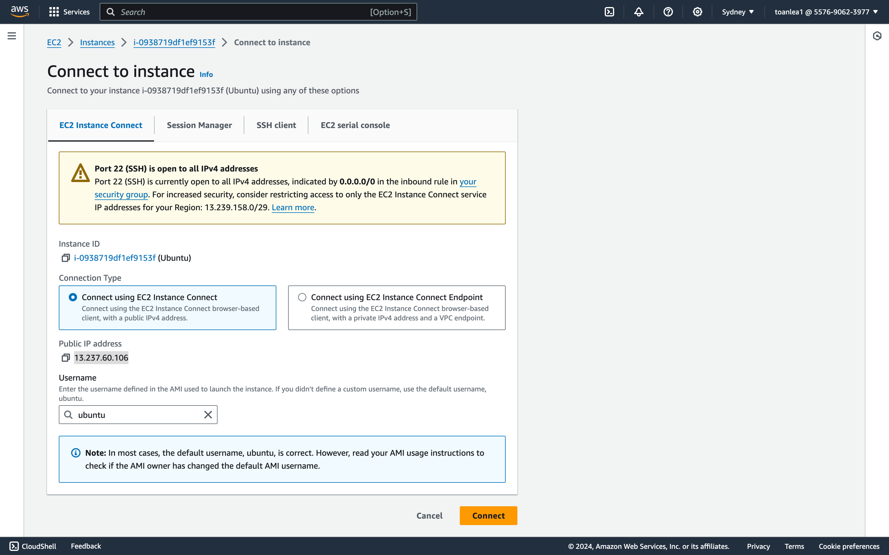

# [5] Setup Jenkins

## Install

Install Jenkins on EC2 instance (Refer to <https://medium.com/@shubnimkar/how-to-install-jenkins-on-aws-ec2-ubuntu-b31dc03719ab>)

**Connect to EC2 – ubuntu instance to install Jenkins**

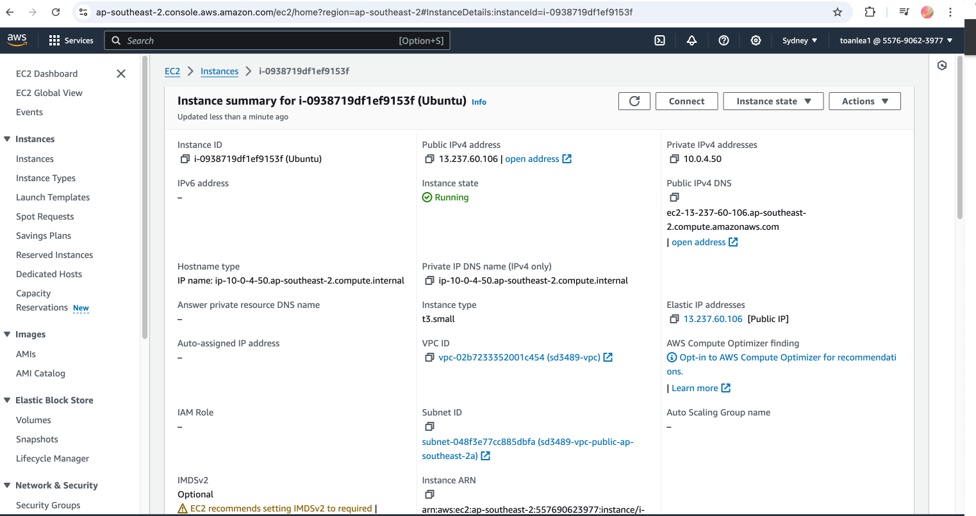

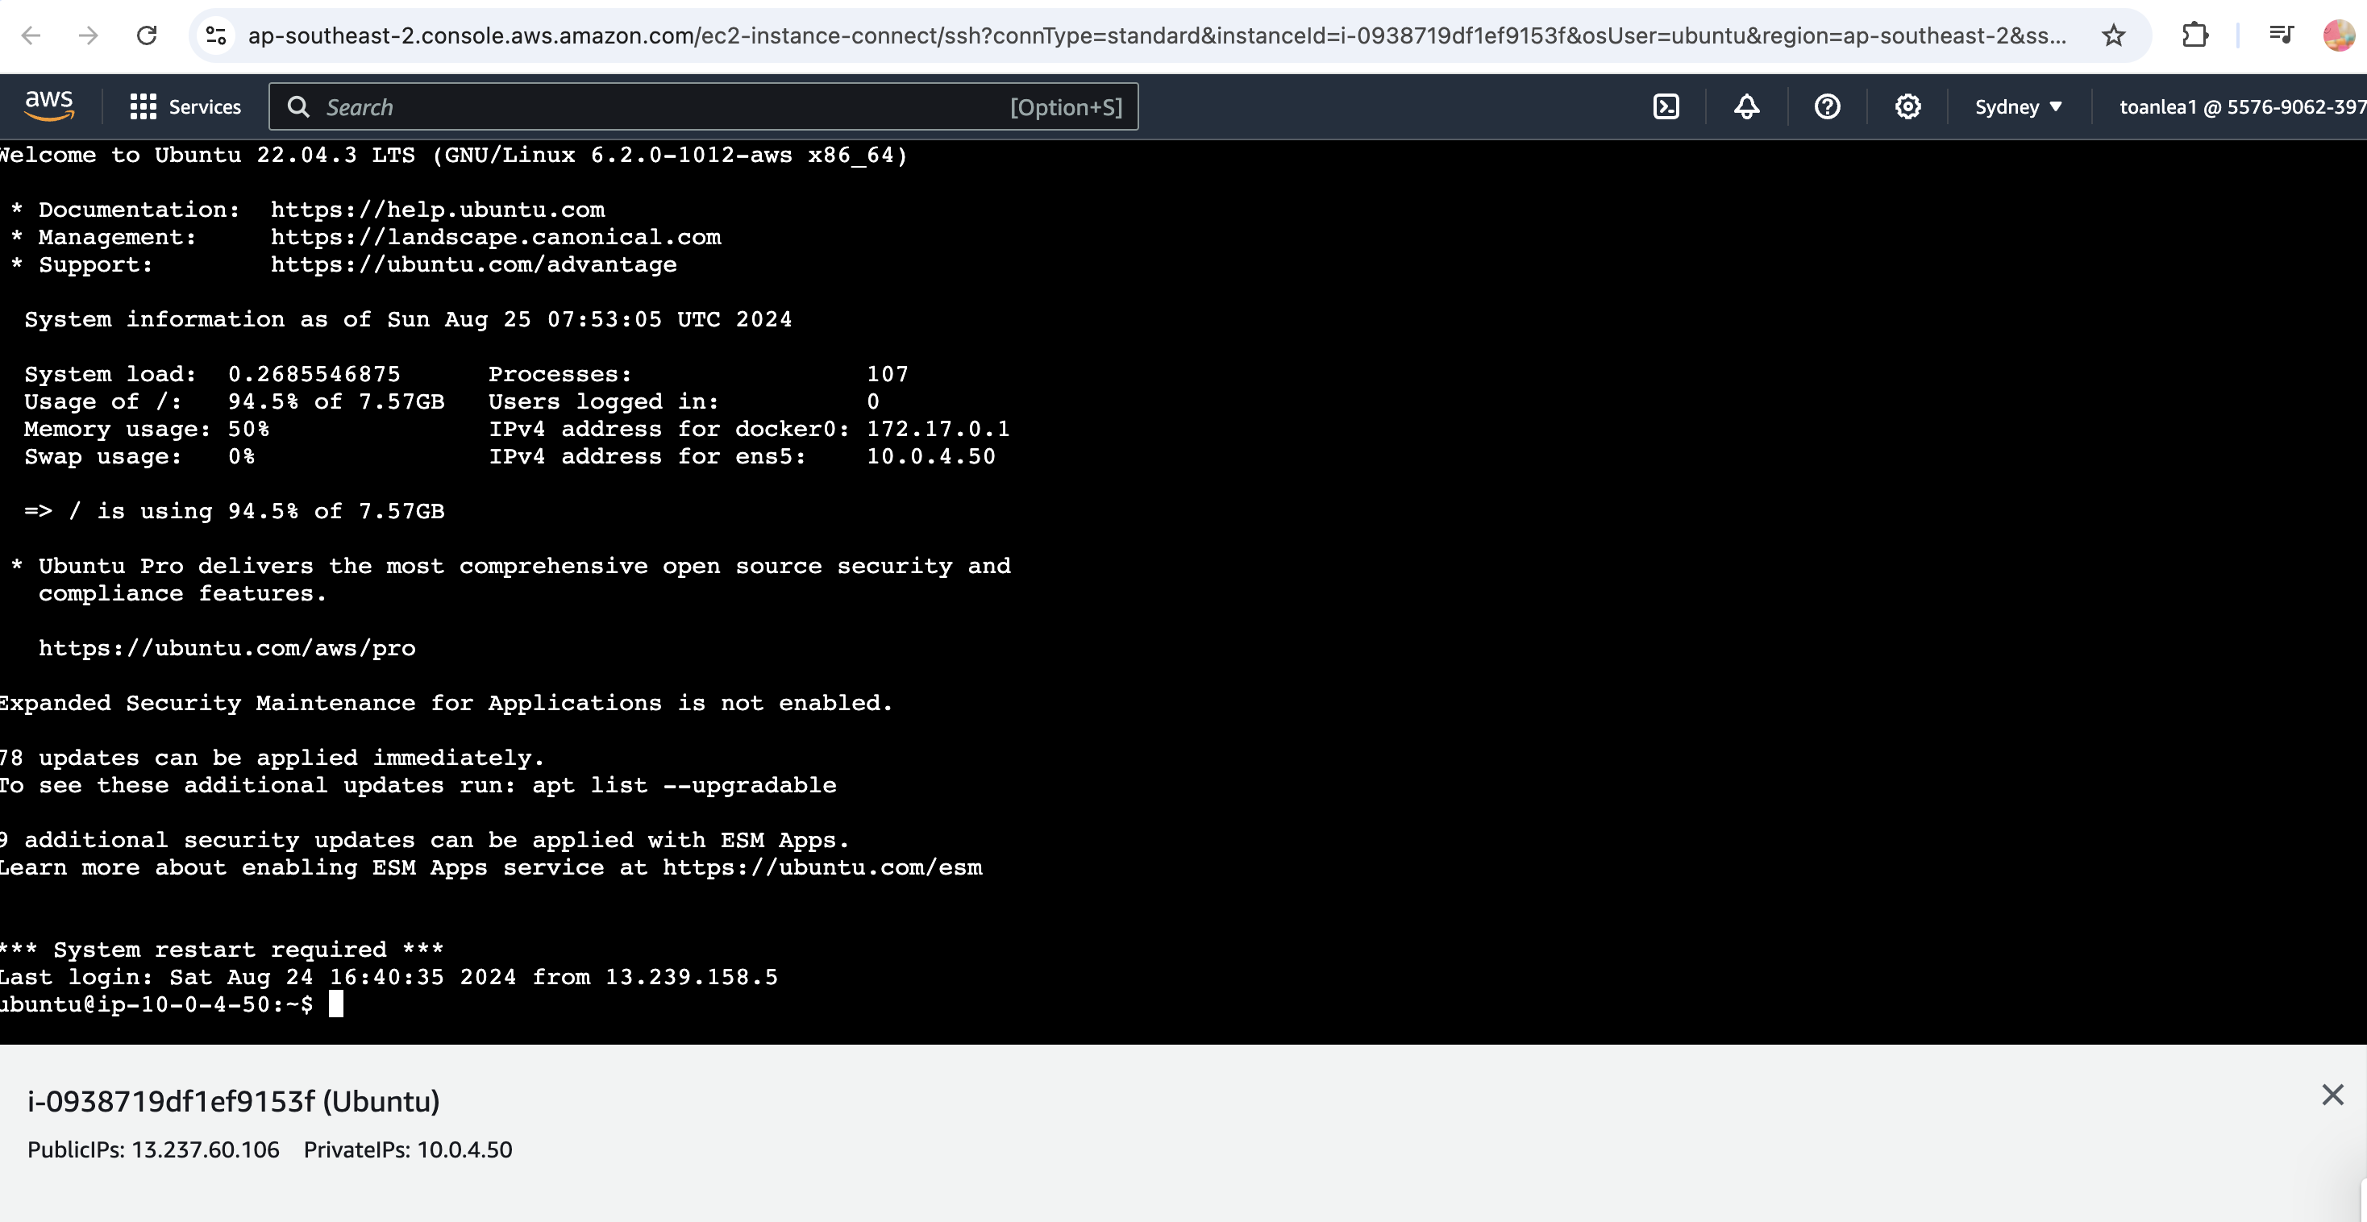

Install Java:

sudo apt install openjdk-11-jdk

Add Jenkins Repo:

wget -q -O - https://pkg.jenkins.io/debian/jenkins.io.key | sudo apt-key add -   
sudo sh -c 'echo deb http://pkg.jenkins.io/debian-stable binary/ > /etc/apt/sources.list.d/jenkins.list'

Add the GPG key for Jenkins repo:

sudo apt-key adv --keyserver keyserver.ubuntu.com --recv-keys {GPK_PUBLIC_KEY}

Install Jenkins

sudo apt update sudo apt install jenkins

Start Jenkins

sudo systemctl start jenkins

Enable Jenkins service to start on the system boot

sudo systemctl enable jenkins

**Check EC2 Security Group Rules:**

* Make sure that the EC2 instance’s security group allows incoming traffic on port 8080.
* Go to the AWS Management Console, navigate to the EC2 instance, and check the associated security group’s inbound rules. Add a rule allowing incoming traffic on port 8080.

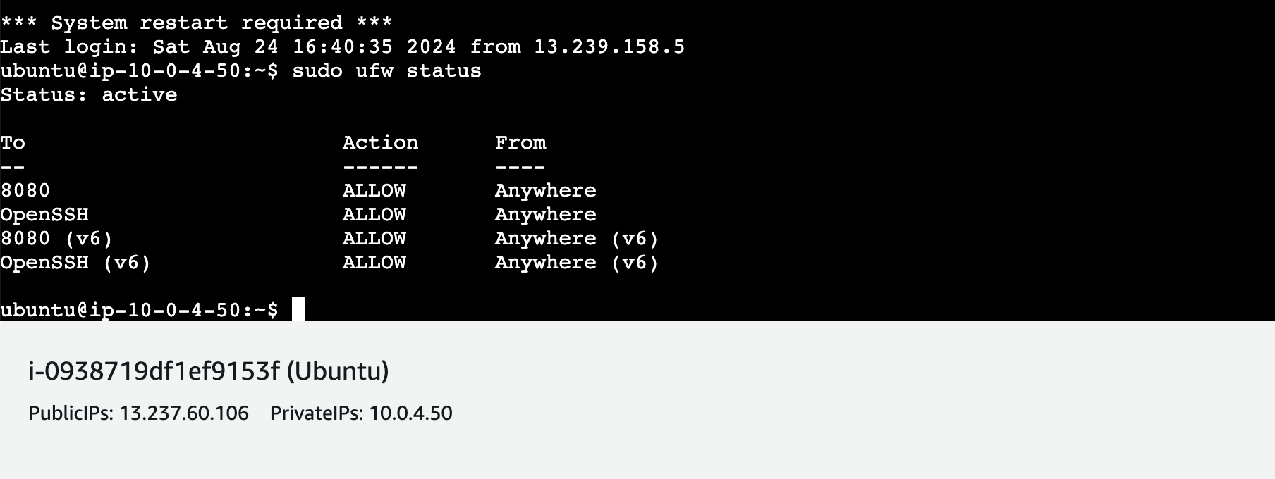

**Access UI Jenkins via Public IP of EC2 instance with 8080 port via** <http://my-public-ip:8080> (By default, Jenkins runs on port 8080)

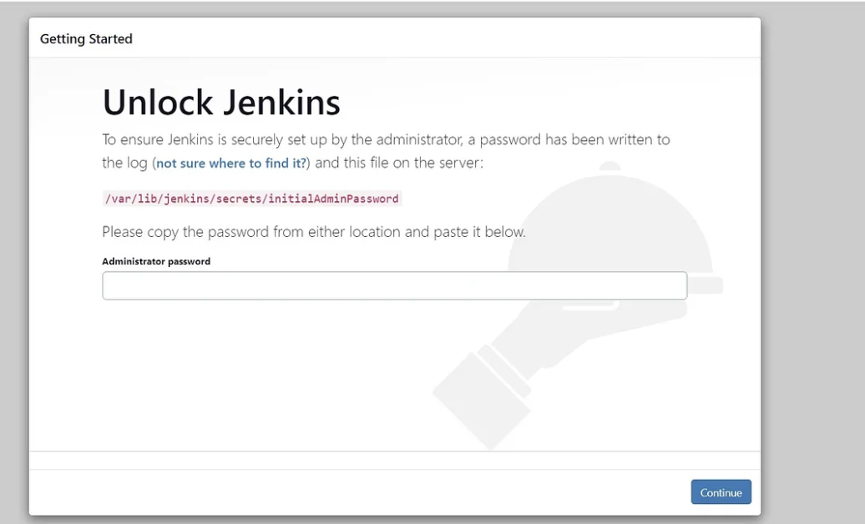

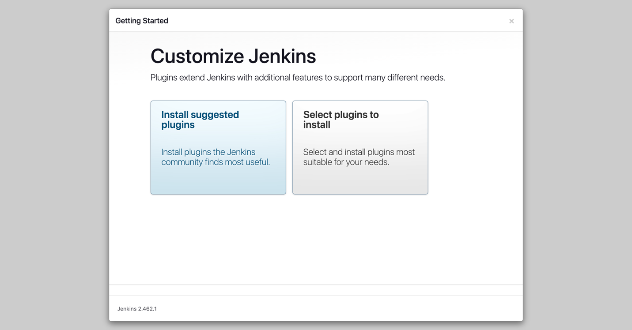

**Follow the guideline and install recommended Jenkins Plugins**

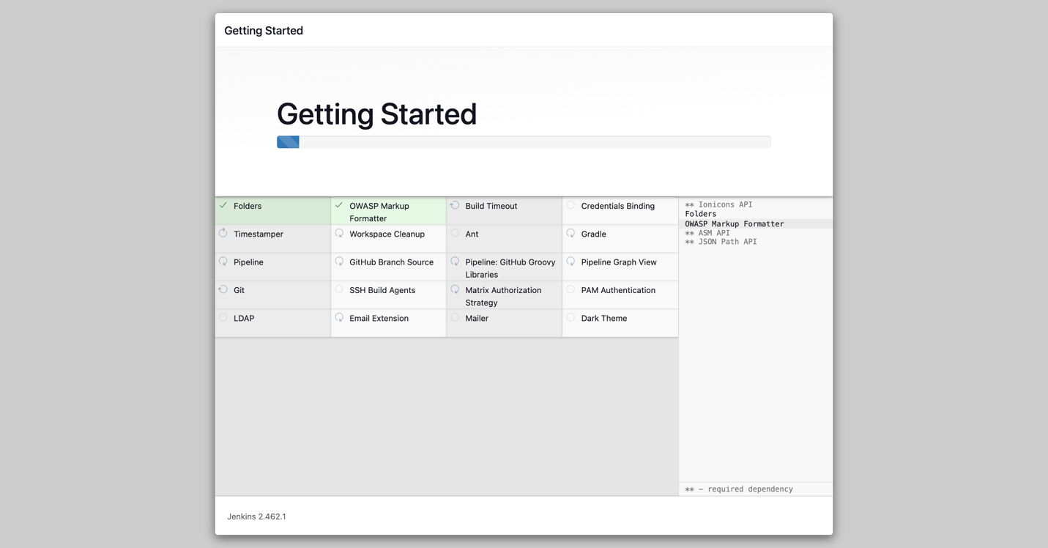

## Additional Jenkins plugins

* **Docker pipeline**

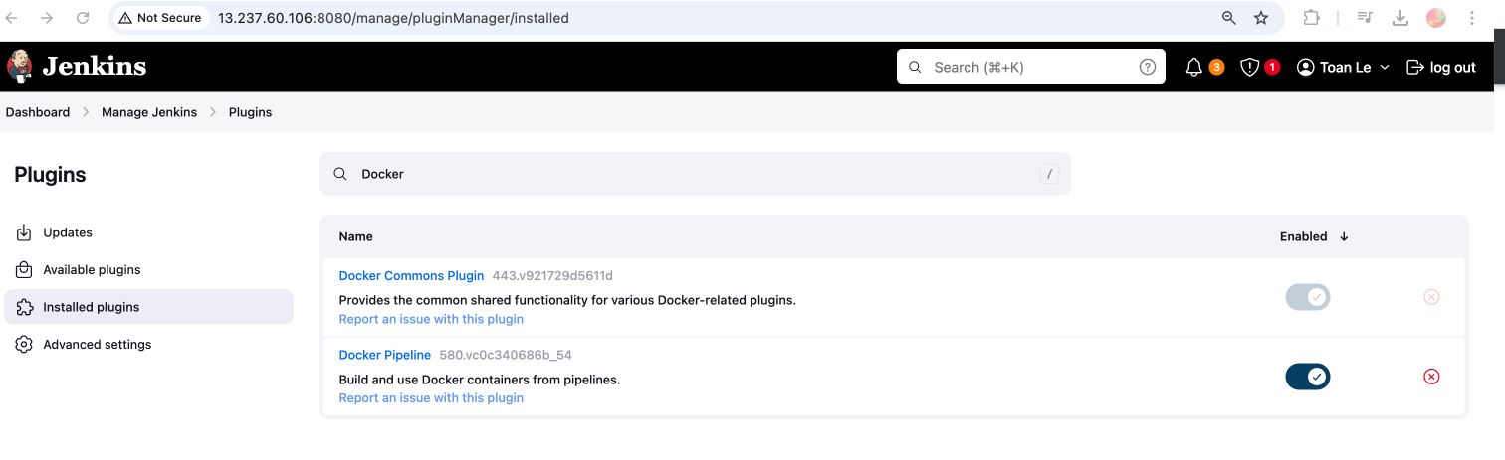

* **Kubernetes plugin  
  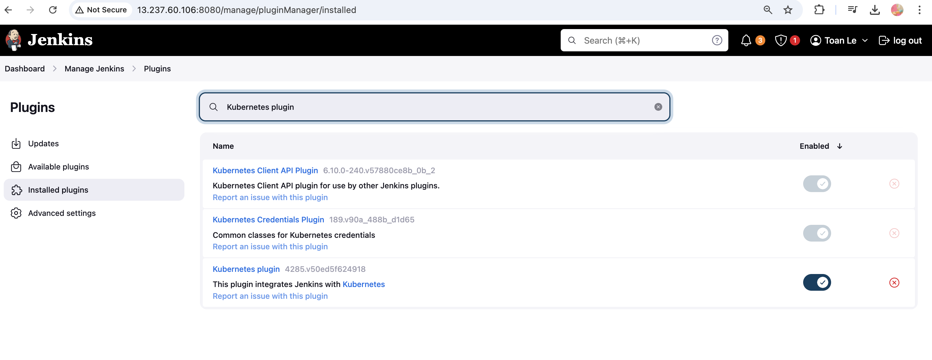**
* **Pipeline utility  
  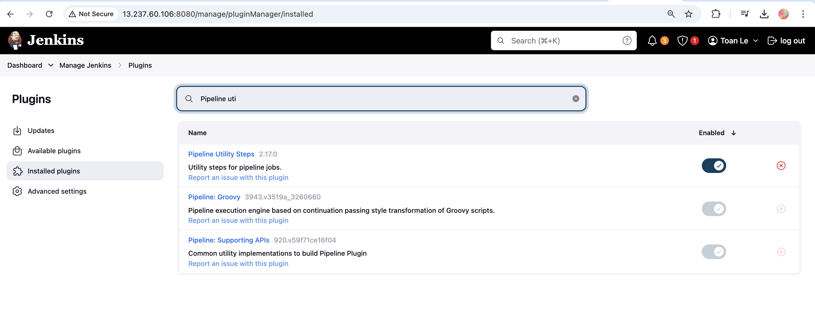**
* **Aamazon EC2  
  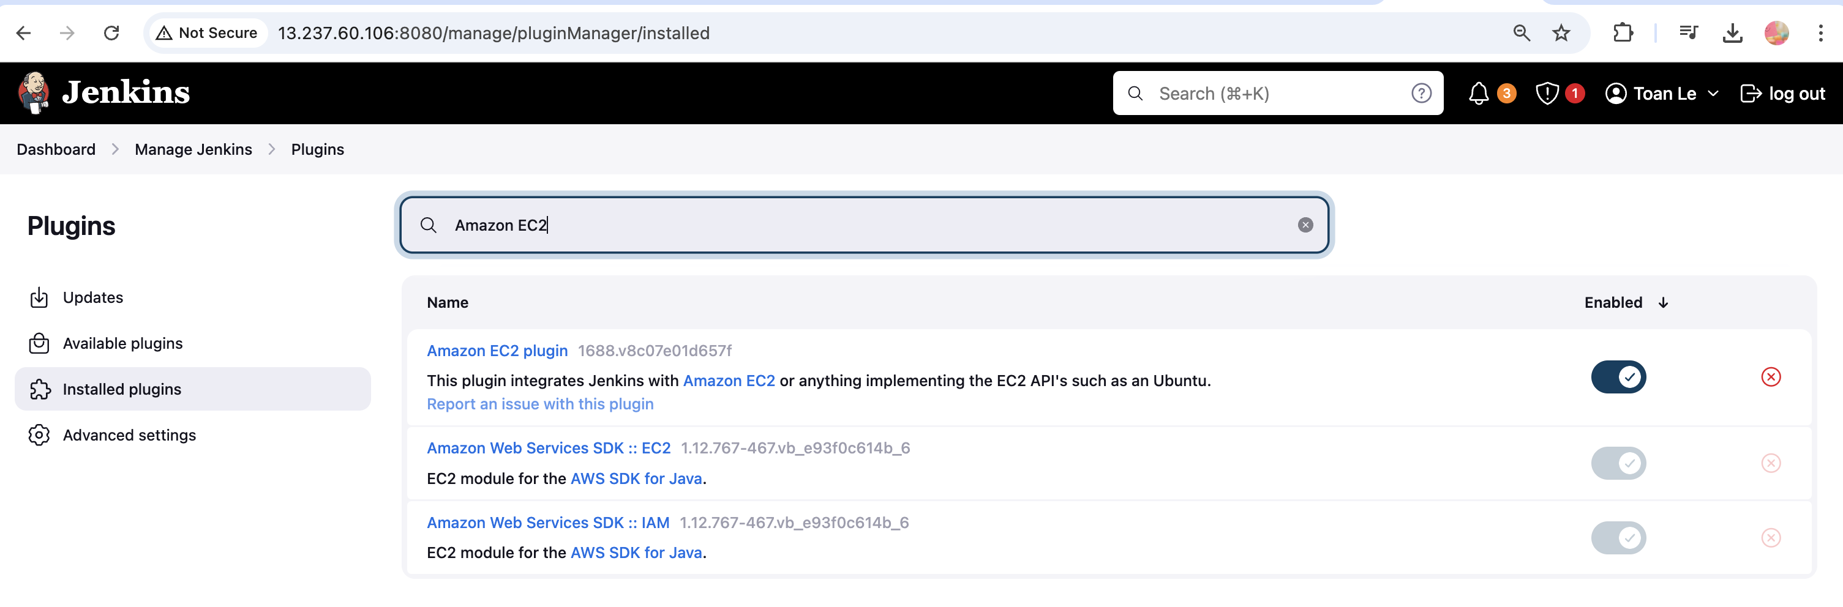**
* **Pipeline: AWS Step  
  **

Setup Credentials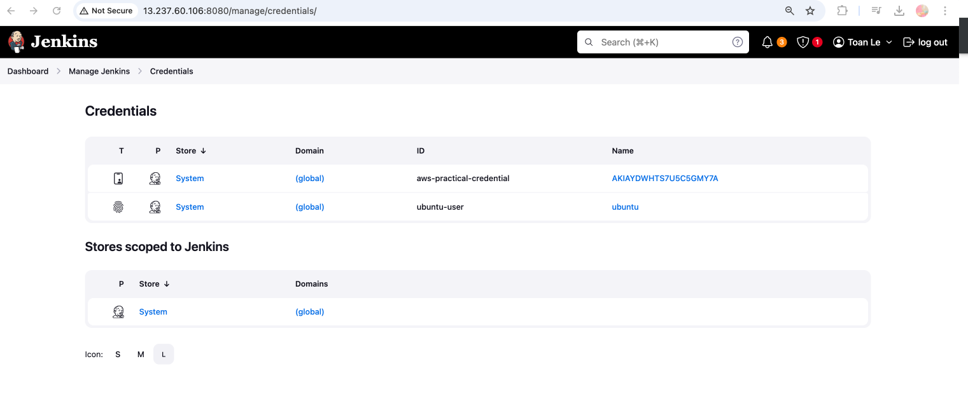

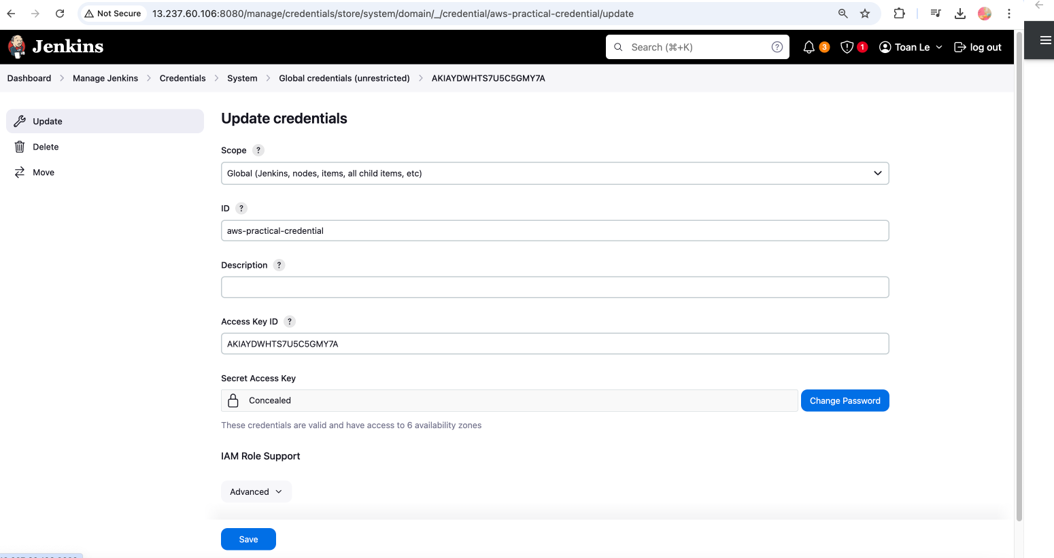

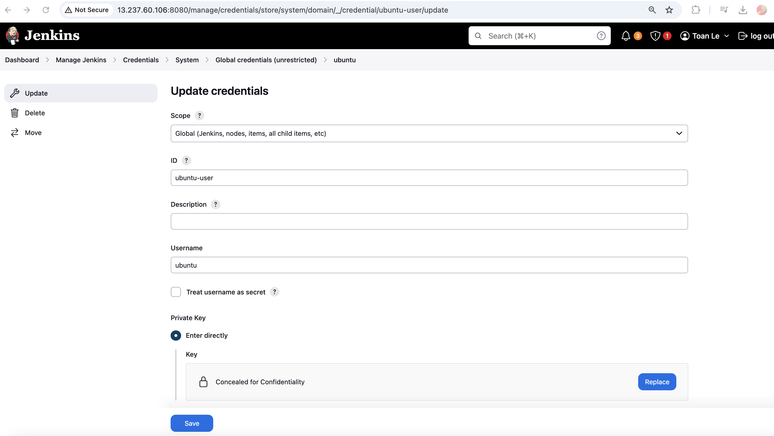

## Create a Job [Pipeline) Jenkins

A job called [AWS Practical Devops]

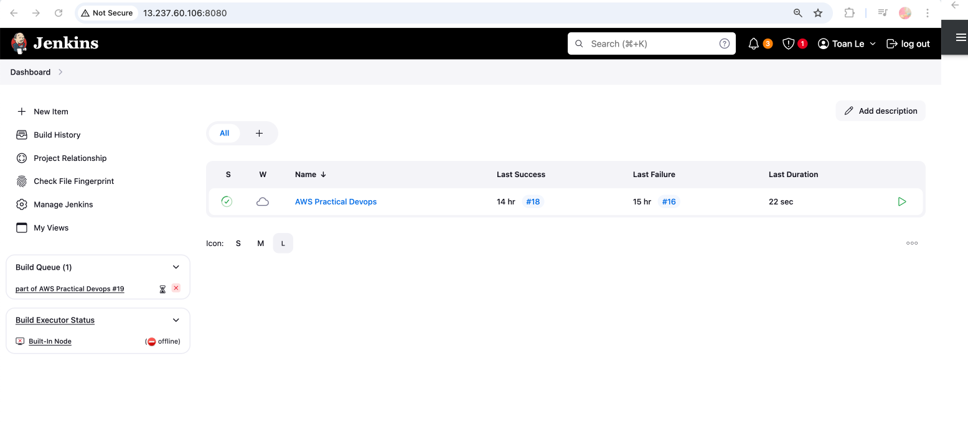

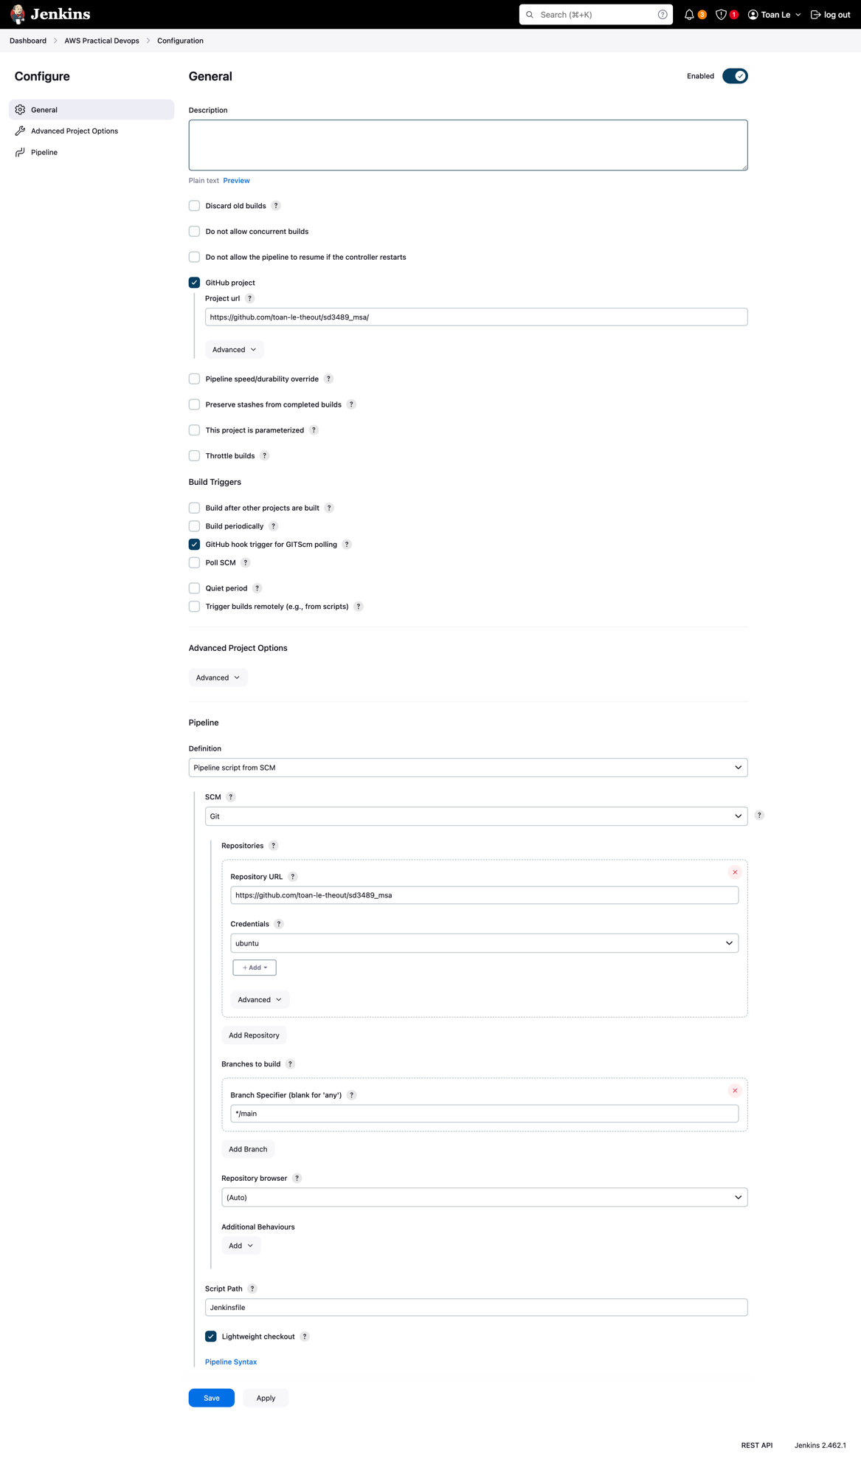

## Build images and push to AWS ECR

By trigger a Build In Jenkins with [Build Now]

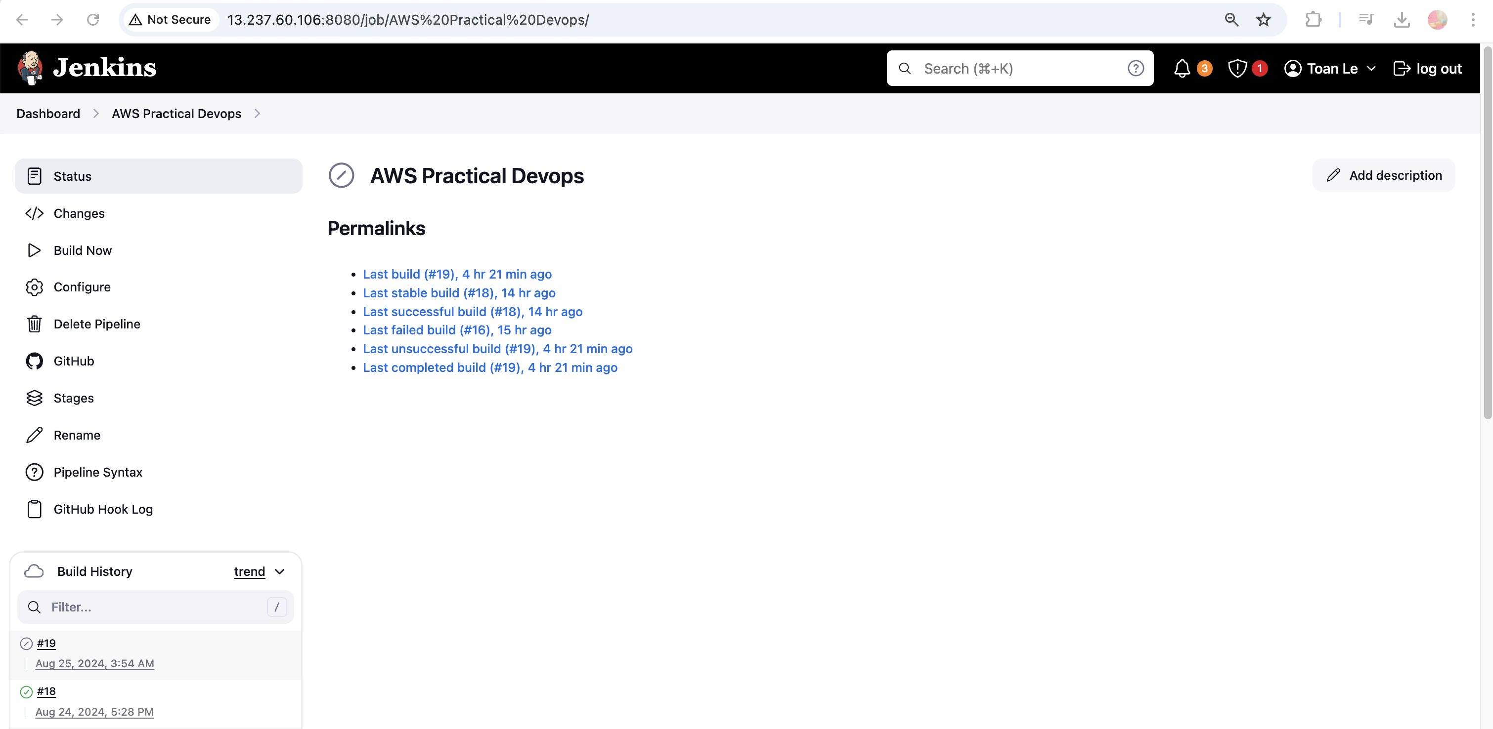

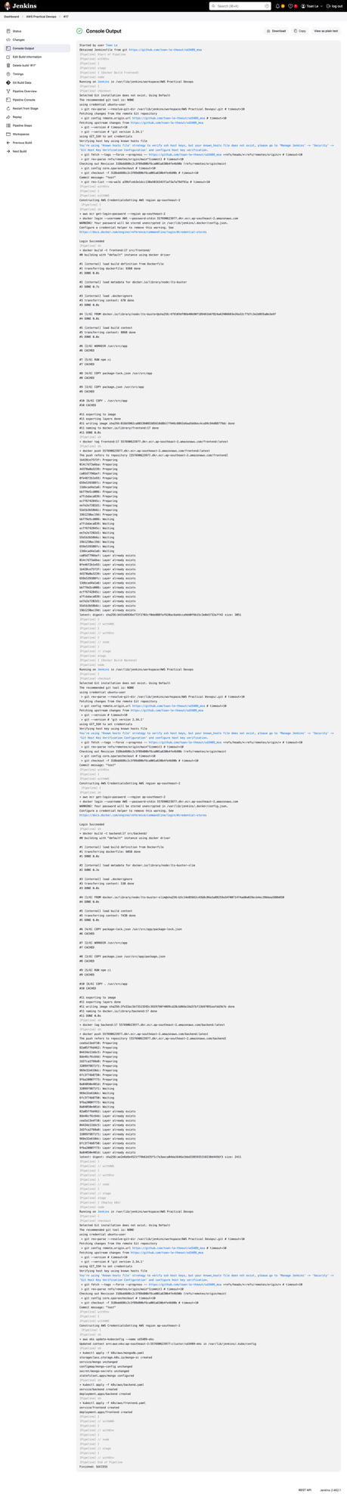

**Let’s see on AWS Services**

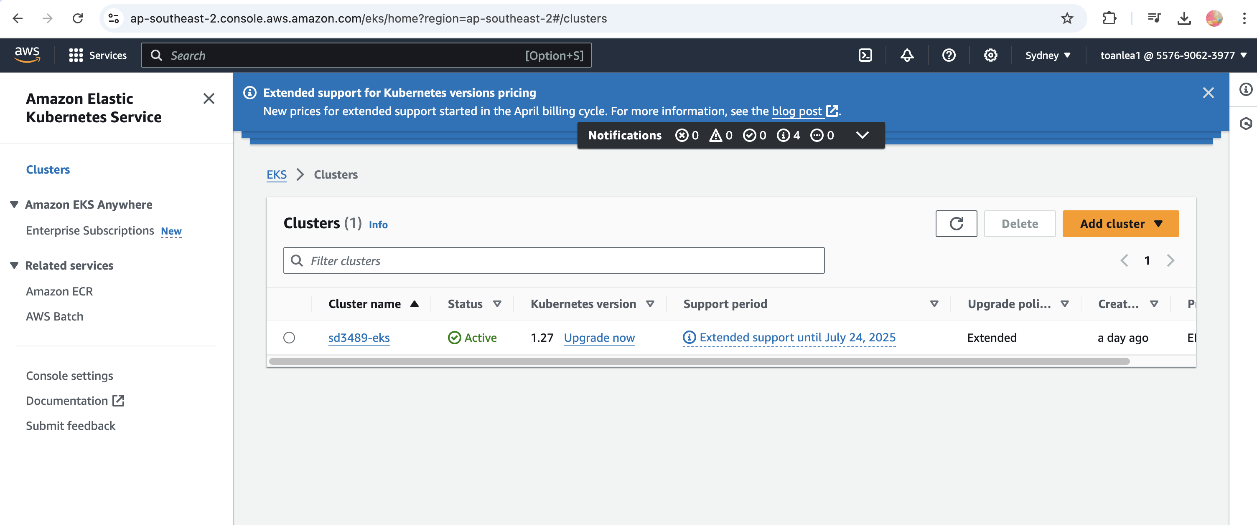

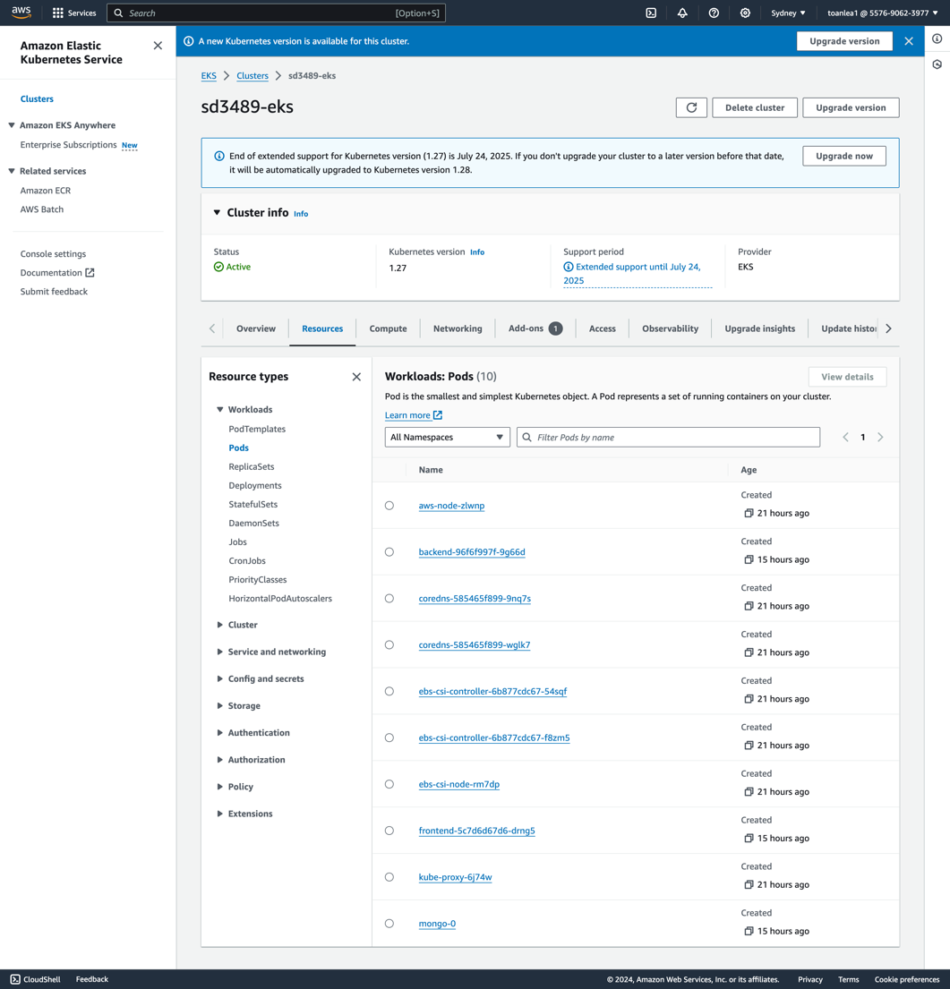

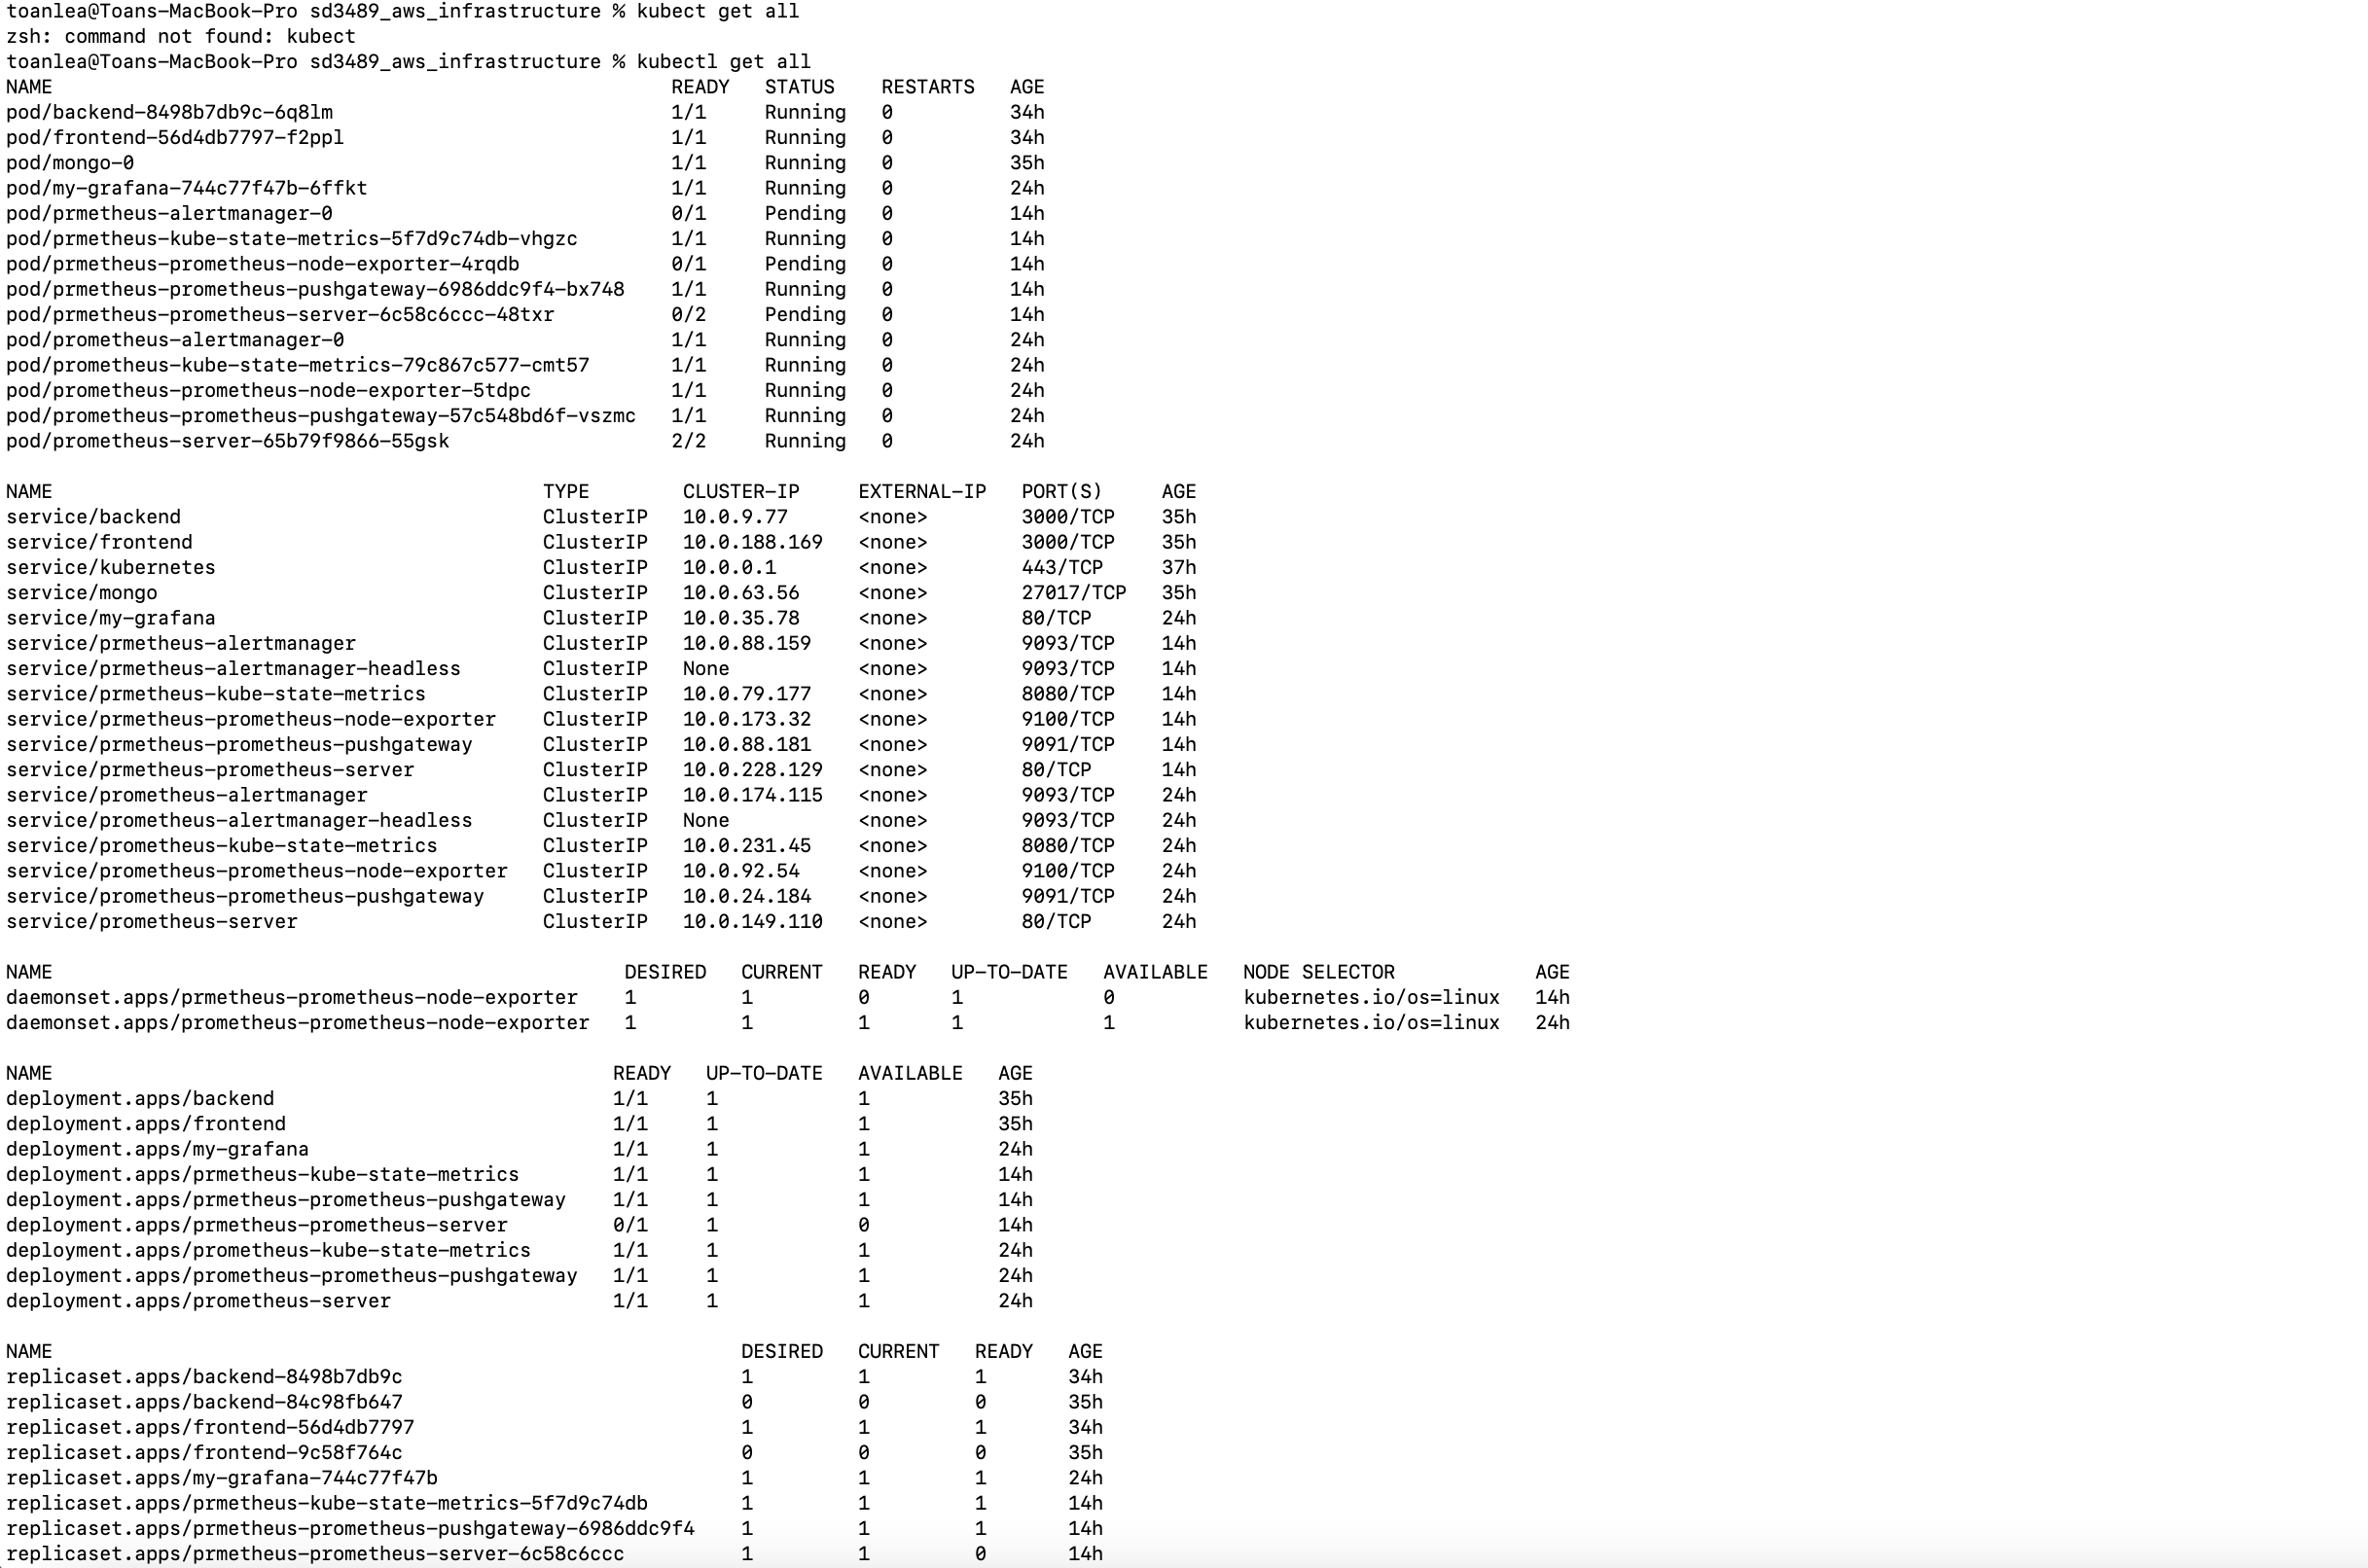

**Run front-end service locally**

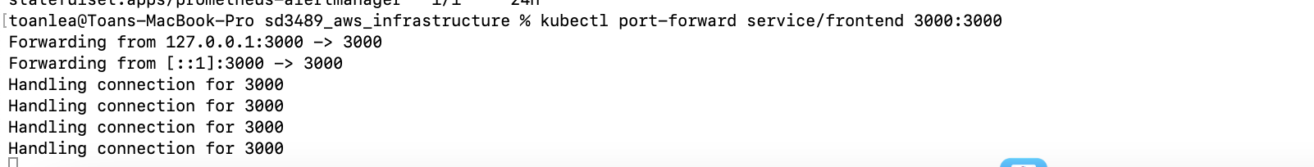

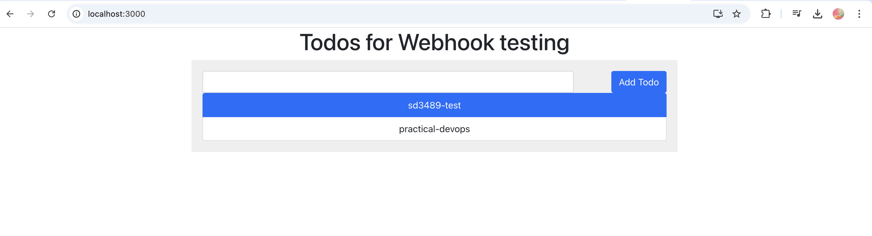

## Config Webhook to trigger the Jenkins Pipeline from Github hook

* **Setup Github’s webhook**Go to MSA application repo’s setting (<https://github.com/toan-le-theout/sd3489_msa/settings>), select [Webhook] set as below:

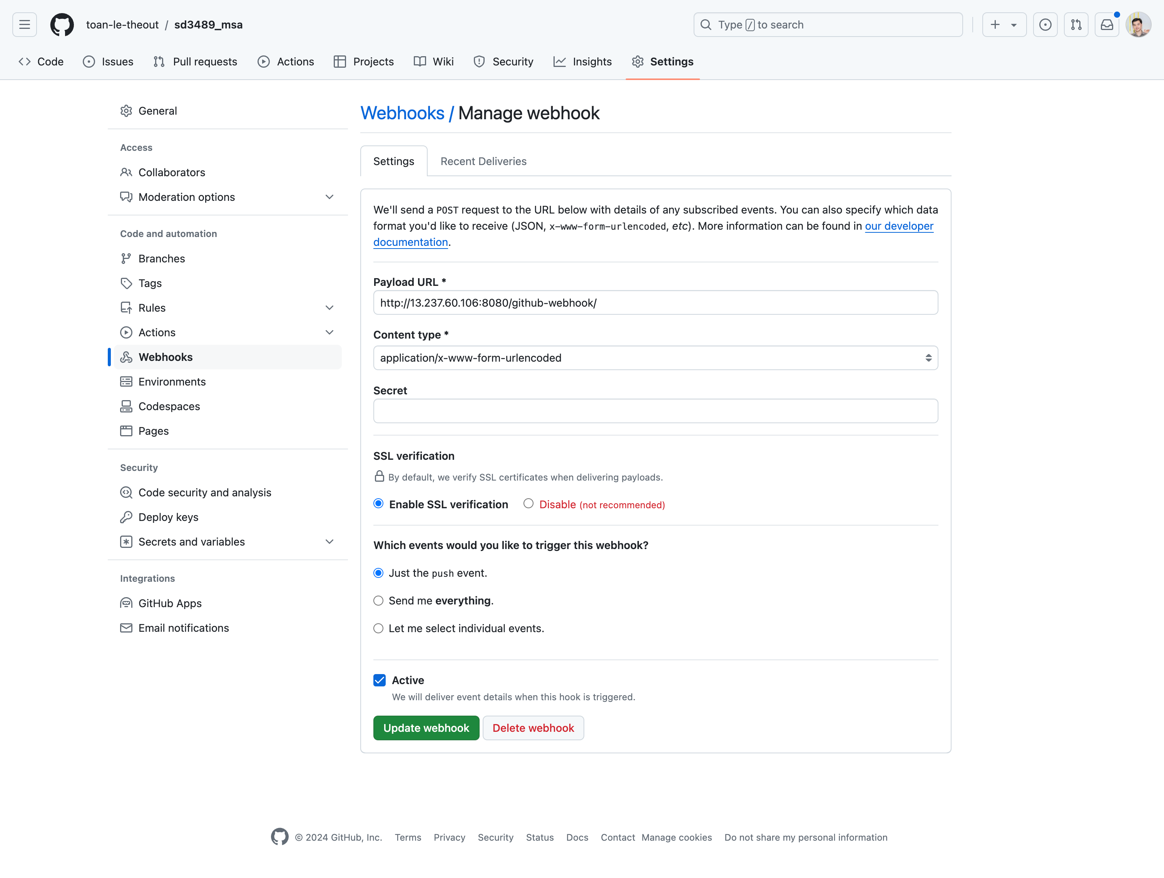

Go to Jenkins Pipeline Job, make sure you have enabled [GitHub] hook trigger for GITScm pollling

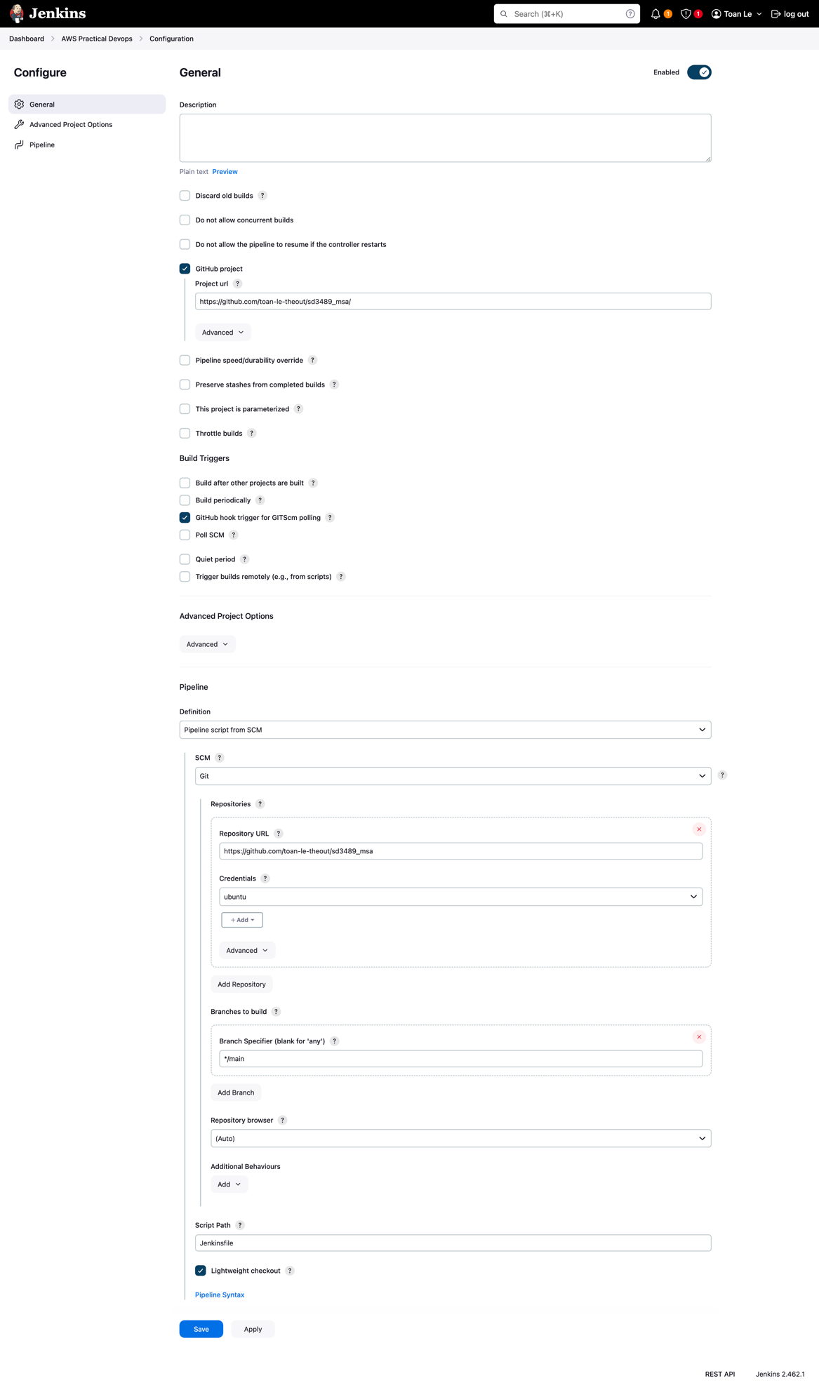

Commit a change and push to the MSA Github repo to see a build triggered automatically in Jenkins Pipeline job and Github’s webhook status:  
  
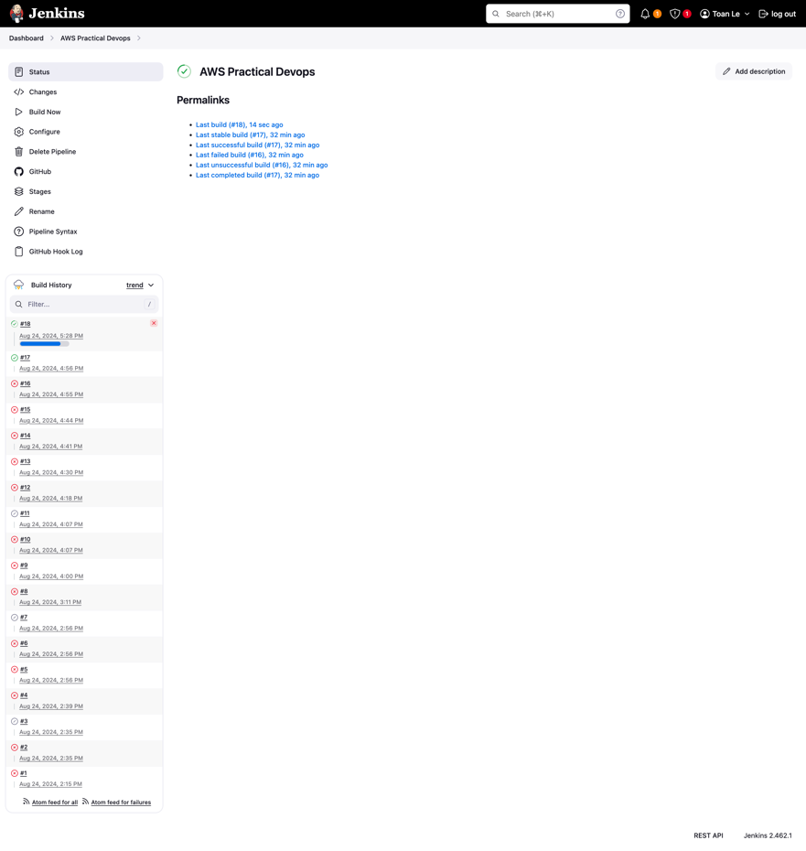

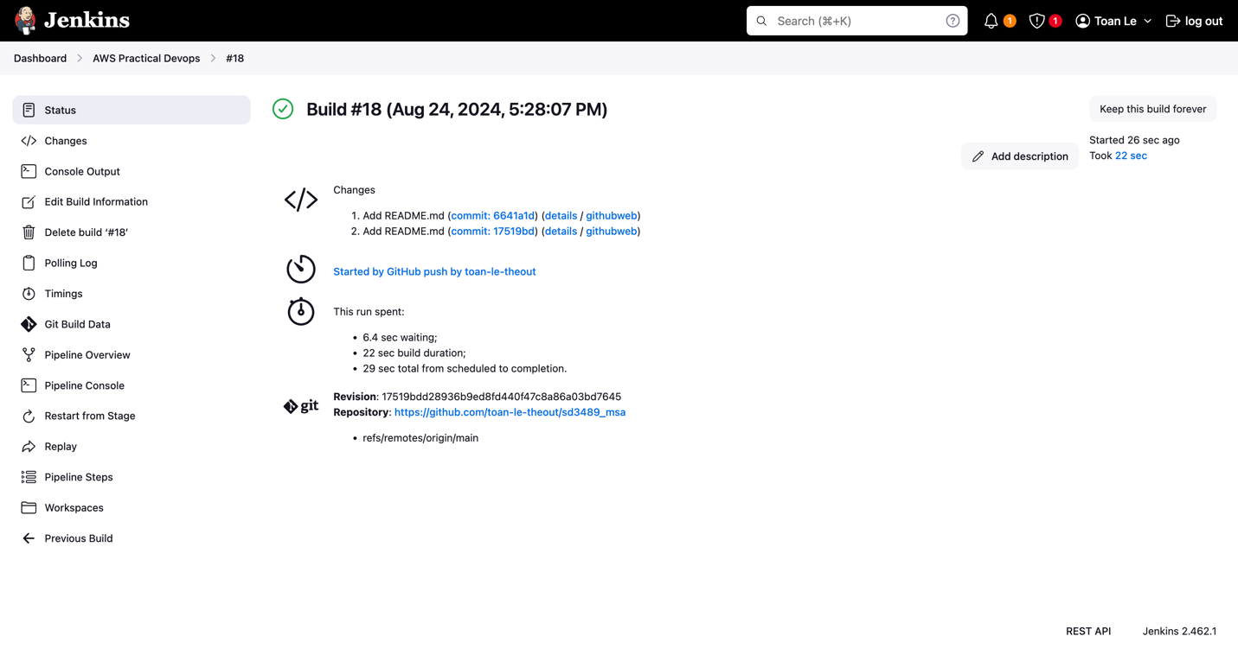

* **Github’s webhook status  
  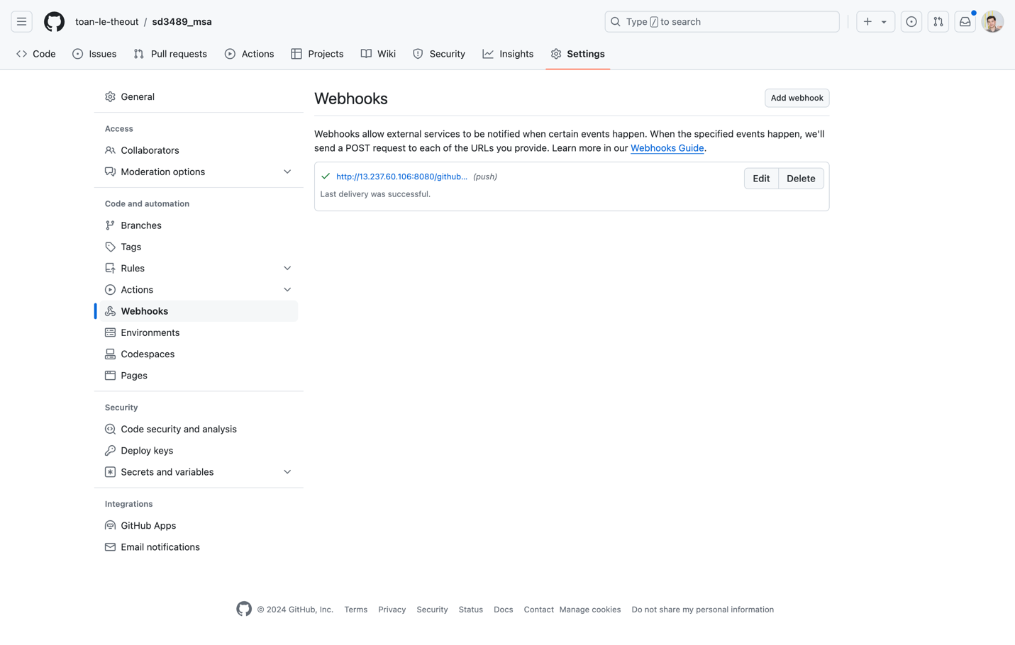**

**Get all from K8s**

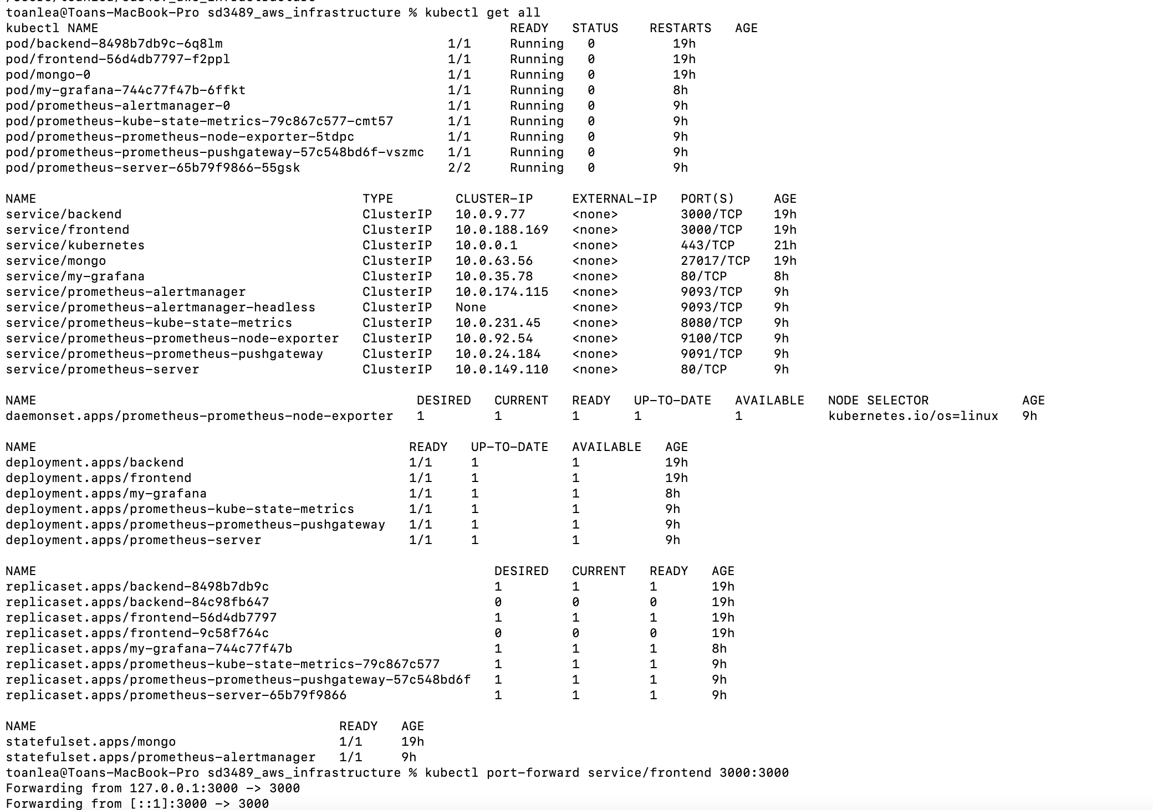

# [6] ArgoCD

## Install

**More details: refer to** [**https://blog.nashtechglobal.com/how-to-create-applications-in-argocd/**](https://blog.nashtechglobal.com/how-to-create-applications-in-argocd/)

* **Create namespace called [argocd]**

Kubectl create namespace argocd

* **Apply YAML file (install all the necessary things)**

**kubectl apply -n argocd -f https://raw.githubusercontent.com/argoproj/argo-cd/stable/manifests/install.yaml**

* **Check pods**

kubectl get pods -n argocd

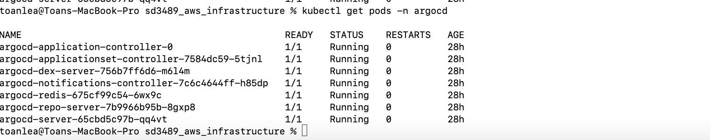

* **Set Port-forward to access locally**

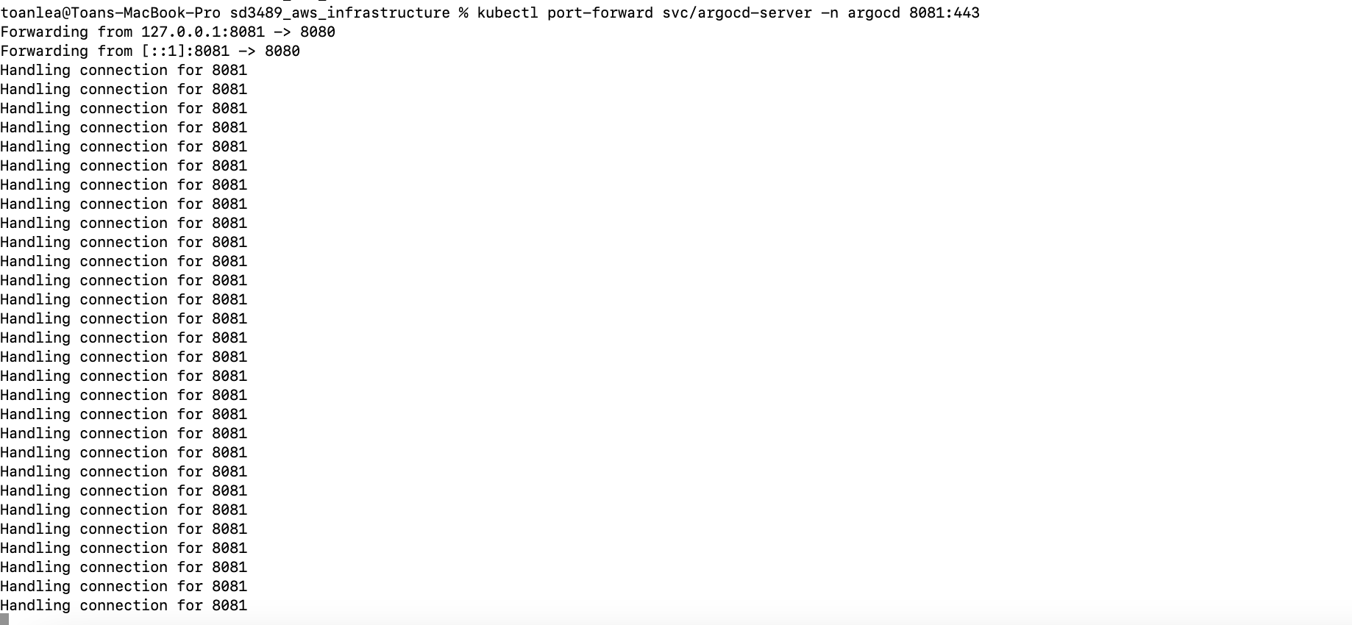

## Sign in to ArgoCD

**https://localhost:8081/**

The password for admin is stored in secret with the name- argocd-initial-admin-secret and also decodes the password.

**Command:**

Getting initial password: kubectl get secrets -n argocd argocd-initial-admin-secret -o yaml   
  
Decode the password: echo ZVF1ZHVZU21OR1RqTFViWg== | base64 --decode

## Create an application

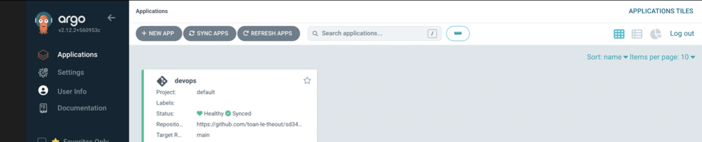

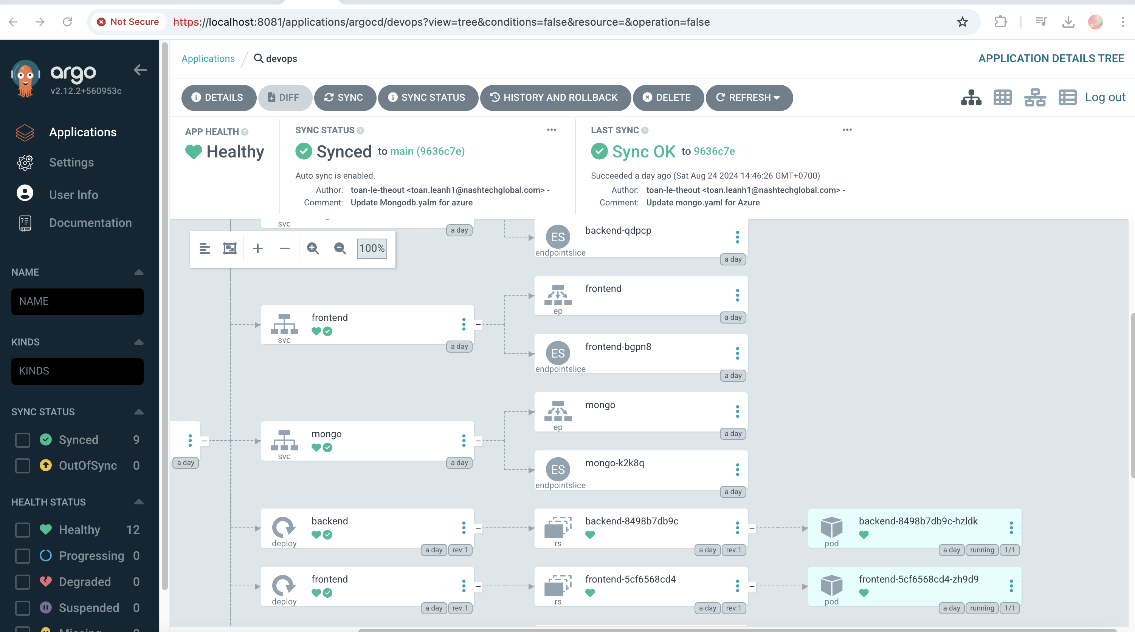

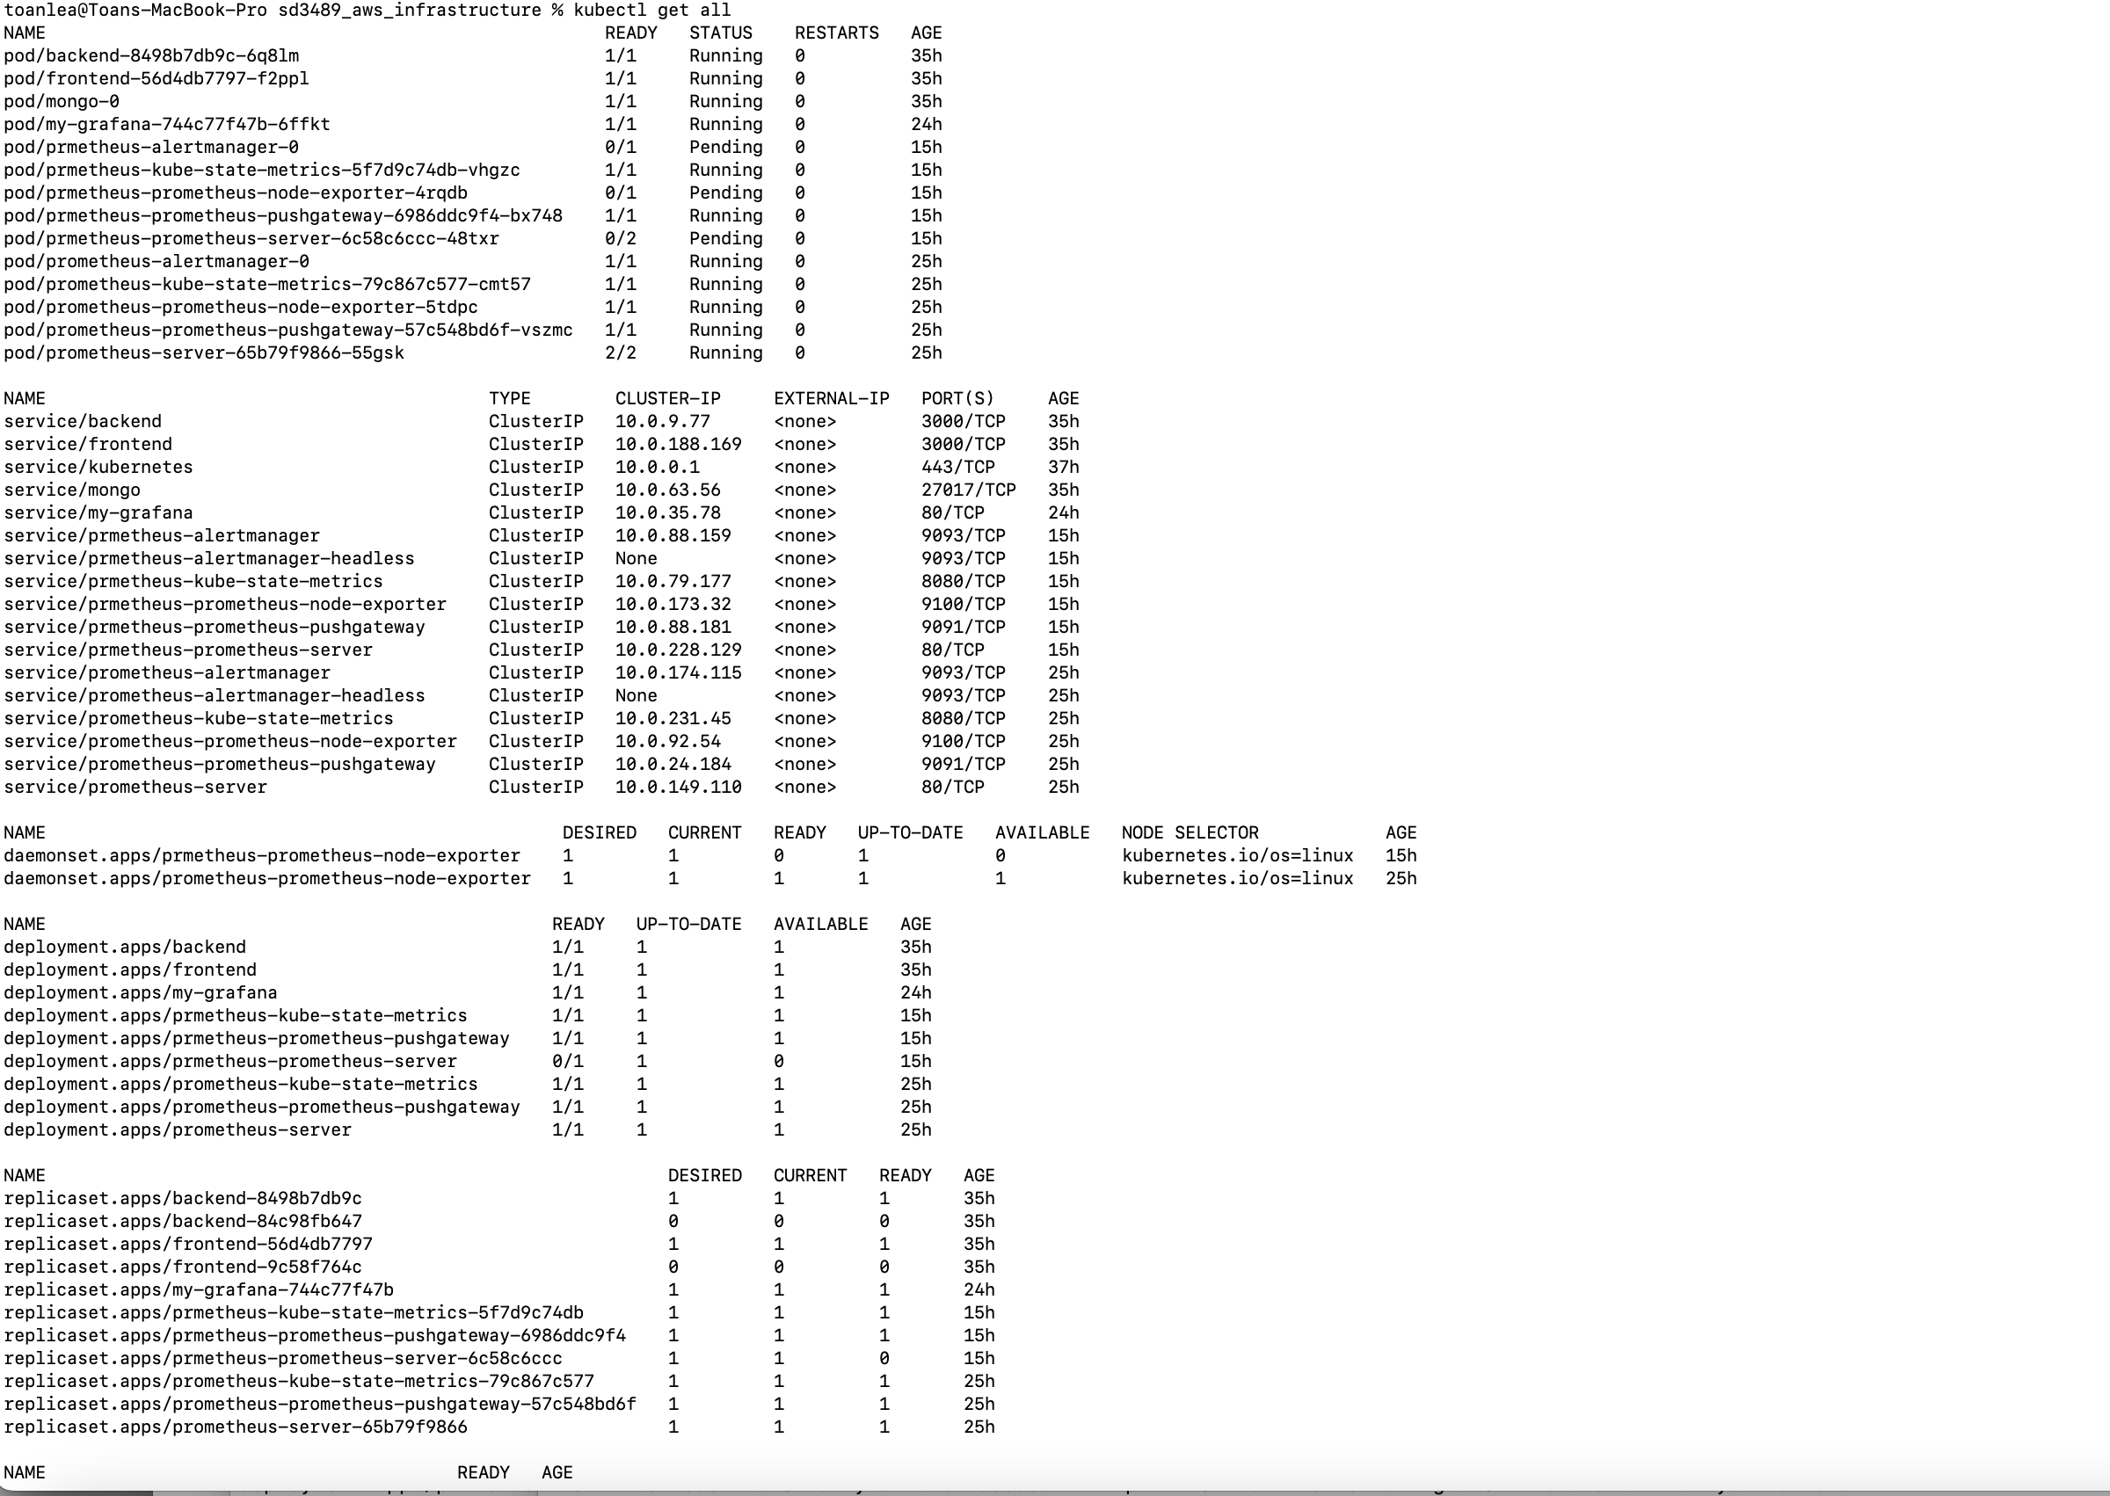

# [7] Monitoring with Prometheus and Grafana

## Install

* Please read README.md of <https://github.com/toan-le-theout/sd3489_msa>
* <https://medium.com/@gayatripawar401/deploy-prometheus-and-grafana-on-kubernetes-using-helm-5aa9d4fbae66>

Set port-forward and access Grafana UI

```

Kubectl port-forward [Grafana-service] host_port:container_port

```

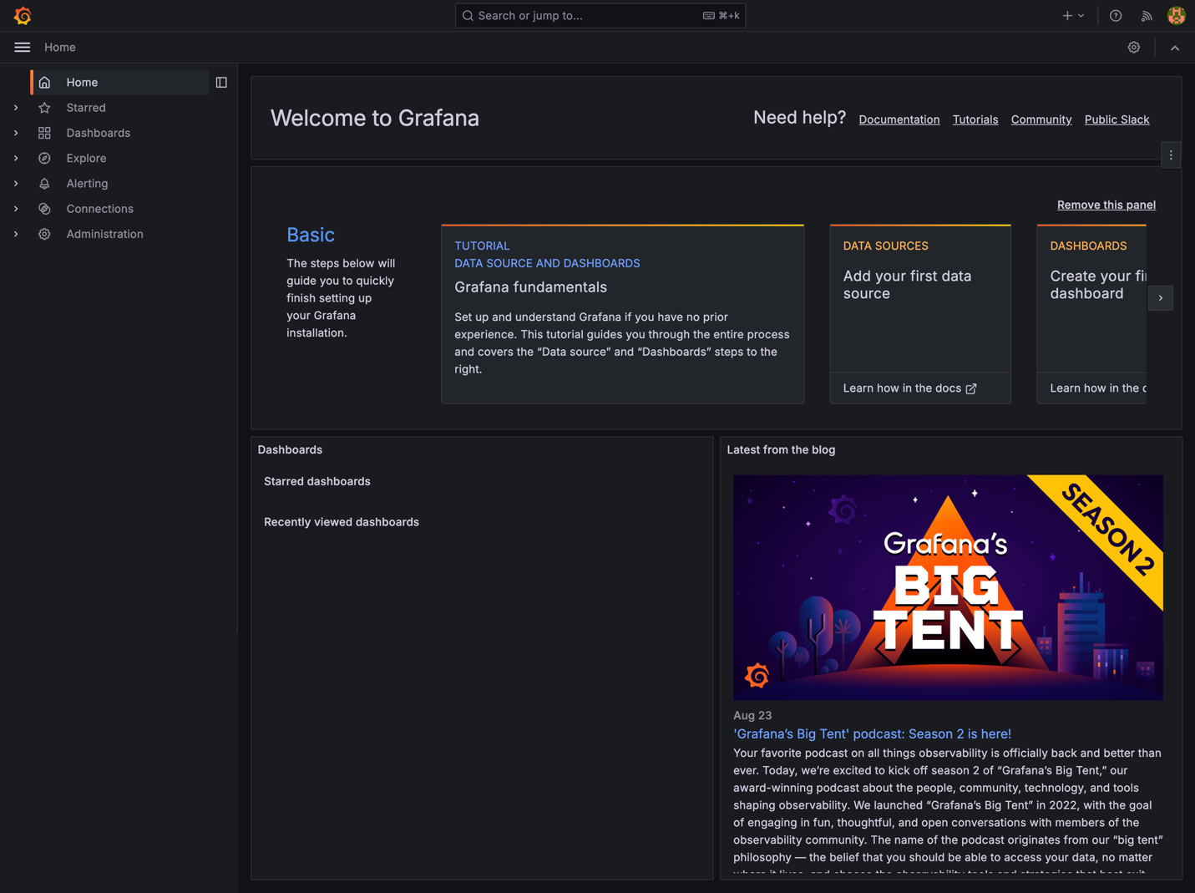

## Import metrics to Dashboard

## 

## Monitoring via UI (Dashboard)

